|  |  |  |  |  |
| --- | --- | --- | --- | --- |
|  |  | | |  |
|  |  | | |  |
|  | Integrated Dash Camera Feature  <<Feature>> | | |  |
|  |  | | |  |
| Document Type | **Feature Document (FD)** | | |  |
| Template Version | **6.1b** | | |  |
| SysML Report Template Version | **O Beta (4/19/2021)** | | |  |
| Document ID | **ffst01.10_featuredocument_sysmlreporttemplate** | | |  |
| Document Location |  | | |  |
| Document Owner | **Malik Eteer** | | |  |
| Document Revision | **FD0** | | |  |
| Document Status | **Draft** | | |  |
| Date Issued | **2021/05/19** | | |  |
| Date Revised | **2021/05/19** | | |  |
| Document Classification | GIS1 Item Number: | **27.60/35** | |  |
| GIS2 Classification: | **Confidential** | |
|  | | | | |
|  | | | | |
| Document Approval | | | | |
| Person | Role | | Email Confirmation | Date |
|  |  | |  |  |
|  |  | |  |  |

**Auto-Generated by MagicDraw**

Printed Copies Are Uncontrolled

# Disclaimer

**This document contains Ford Motor Company Confidential information. Disclosure of the information contained in any portion of this document is not permitted without the expressed, written consent of a duly authorized representative of Ford Motor Company, Dearborn, Michigan, U.S.A.**

**Copyright, Ó 2021 Ford Motor Company**

This document contains information developed and accumulated by and for FORD MOTOR COMPANY. As such, it is a proprietary document, which, if disseminated to unauthorized persons, would provide others with restricted information, data, or procedures not otherwise available, exposing the FORD MOTOR COMPANY to potential harm.

Employees and suppliers having custody of this specification or authorized to use it must be cognizant of its proprietary nature and ensure that the information herein is not made available to unauthorized persons.

FORD MOTOR COMPANY reserves the right to protect this work as an unpublished copyrighted work in the event of an inadvertent or deliberate unauthorized publication. FORD MOTOR COMPANY also reserves its rights under copyright laws to protect this work as a published work.

This document or portions thereof shall not be distributed outside FORD MOTOR COMPANY without prior written consent. Refer all questions concerning disclosure to the author(s) or to any duly authorized representative of Ford Motor Company.

# Contents

1.1.2 Decomposition of Functional Safety Requirement 13

Disclaimer 22

Contents 23

2 Introduction 26

2.1 Document Purpose 26

2.2 Document Scope 26

2.3 Document Audience 26

2.3.1 Stakeholder List 26

2.4 Document Organization 26

2.4.1 Document Context 26

2.4.2 Document Structure 27

2.5 Document Conventions 27

2.5.1 Requirements Templates 27

3 Feature Overview 28

3.1 Purpose and Description of Feature 28

3.2 Feature Variants 28

3.2.1 Regions & Markets 29

3.3 Input Requirements 29

3.3.1 Legal Requirements 30

3.3.2 Trustmark Requirements 30

3.3.3 Industry Standards 30

3.3.4 Attribute Requirements 30

3.4 Lessons Learned 30

3.5 Assumptions 31

3.6 References 31

3.6.1 Ford Documents 32

3.6.2 External Documents and Publications 32

3.7 Glossary 33

3.7.1 Parameters / Values 33

4 Feature Context 34

4.1 Feature Context Diagram 34

4.2 List of Influences 34

5 Feature Modeling 36

5.1 Operation Modes and States 36

5.2 Use Cases 38

5.2.1 Use Case Diagram 38

5.2.2 Actors 39

5.2.3 Use Case Descriptions 39

5.3 Driving and Operation Scenarios 43

5.4 Decision Tables 45

6 Feature Requirements 46

6.1 Functional Requirements 46

6.1.1 Error Handling 47

6.2 Non-Functional Requirements 47

6.2.1 Safety 47

6.2.2 Security 47

6.2.3 Reliability 47

6.3 HMI Requirements 47

6.4 Other Requirements 48

6.4.1 Design Requirements 48

6.4.2 Manufacturing Requirements 48

6.4.3 Service Requirements 48

6.4.4 After Sales Requirements 48

6.4.5 Process Requirements 48

6.4.6 Uncategorized Requirements 49

7 Functional Safety 50

7.1 System Behaviors for HARA 50

7.2 Safety Assumptions 50

7.3 Safety Goals 51

7.4 Functional Safety Requirements 53

7.4.1 Safety Goal: 53

7.4.2 Derivation of Functional Safety Requirements on Assumptions 55

7.5 ASIL Decomposition of Functional Safety Requirements 56

8 Architecture 57

8.1 Functional Architecture 57

8.1.1 List of Functions 57

8.2 Logical Architecture 58

8.2.1 Logical Interfaces 59

9 Open Concerns 61

10 Revision History 62

11 Appendix 63

11.1 Definitions 63

11.2 Abbreviations 63

**List of Figures**

Figure 1. 12

Figure 2: 28

Figure 3: - 28

Figure 4: 34

Figure 5: 36

Figure 6: 38

Figure 7:  55

Figure 8: 57

Figure 9: 58

**List of Tables**

Table 1: Features described in this FD 26

Table 2: Feature Variants 29

Table 3: Regions & Markets 29

Table 4: Ford internal Documents 32

Table 5: Ford internal Documents *(not specified in SysML model)* 32

Table 6: External documents and publications 32

Table 7: External documents and publications *(not specified in SysML model)* 33

Table 8: Parameters / Values used in this document *(Not supported by MagicDraw report generation)* 33

Table 9: List of Influences 35

Table 10: Operation Modes and States on 36

Table 11: Transitions between Operation Modes and States on 38

Table 12: List of Actors 39

Table 13: System Behaviors for HARA 50

Table 14: Functional Safety Assumptions 51

Table 15: Functional Safety Goals 53

Table 16: List of Functions 58

Table 17: List of Functions on 58

Table 18: Feature Interactions 59

Table 19: Feature Interactions on 59

Table 20: Open Concerns *(Not supported by MagicDraw report generation)* 61

Table 21: Definitions used in this document 63

Table 22: Abbreviations used in this document 64

# Introduction

## Document Purpose

A Feature Document (FD) document defines a Feature on [Concept Level](https://bd101001.pd2.ford.com/stages/#/workspace/209/_vv/(process/activity/_Y6ftAPI2VsW5zd82DgHb6g)). It specifies **what** the feature shall do and how it shall behave from customer perspective. It should also provide reasoning and background **why** we have the feature in the vehicle.

The FD also serves as an Item Definition as defined by ISO26262 for those features, which follow the Ford Functional Safety process. Refer [FFSG01.10 Feature Document Guideline](https://azureford.sharepoint.com/sites/GlobalFunctionalSafety/Released%20Templates%20Guidelines%20and%20Examples/Guidelines/FFSG01.10_FeatureDocument_Guideline.pdf) for how to apply the Feature Doc template for Functional Safety.

## Document Scope

This Feature Document (FD) specifies the following features:

|  |  |  |  |
| --- | --- | --- | --- |
| **Feature ID** | **Feature Name** | **Owner** | **Reference** |
|  | Integrated Dash Camera Feature  (Program(s): MY2024 CDX 747, CDX 746N) | Malik Eteer |  |

Table 1: Features described in this FD

## Document Audience

The FD is written by the feature owner of Malik Eteer. All Stakeholders, i.e., all people who have a valid interest in the feature should read and, if possible, review the FD. It needs to be guaranteed, that all stakeholders have access to the currently valid version of the FD.

### Stakeholder List

For the latest list of stakeholder of the feature and their influence refer to <Put VSEM Link here>.

|  |  |  |  |  |
| --- | --- | --- | --- | --- |
| **Name** | **CDSID** | **Contact Info** | **Role** | **Stakeholder Group** |
| John Doe |  |  | Model Architect | Systems Engineer |

## Document Organization

### Document Context

Refer to the [Specification Structure page](http://wiki.ford.com/display/RequirementsEngineering/Specification+templates) in the [Ford RE Wiki](http://wiki.ford.com/display/RequirementsEngineering/Requirements+Engineering+for+SW+Enabled+Features) to understand how the FD relates to other Ford Requirements Documents and Specifications.

### Document Structure

The structure of this document is explained below:

**Introduction** – Explains how to use this document including responsibilities and requisite documents. Explains the terminology. Gives a clarification of the definitions, concepts and abbreviations used in the document.

**Feature Overview** – States briefly the background and the purpose of the feature, feature variants and corresponding regions and markets. Also includes input requirements, assumptions and constraints.

**Feature Context** – describes all external entities, which have an influence on the feature.

**Feature Modeling** – Contains Use Case, Driving Scenarios, State Charts to describe the functional behavior of the feature.

**Feature Requirements** – Lists functional and non-functional requirements of the feature.

**Functional Safety** – Lists System Behaviors, Safety Goals and Safety Requirements of the feature.

**Cybersecurity** – Lists Security Goals and Security Requirements of the feature.

**Architecture** – Shows the coarse architecture, which the feature requirements are deployed to. Describes the elements and the boundary of the feature as well as the decomposition and distribution of associated functions.

**Traceability Matrix** – Traceability Matrix.

**Open Concerns** – List of Open Concerns

**Revision History** – Document Change History including a list of new or modified requirements. The requirements in this document are tagged, and this section contains different types of tables listing all, new, or changed requirements by their title and page no.

**Appendix** – Appendix

## Document Conventions

### Classification of Chapters

A chapter is considered mandatory, unless the chapter or its parent chapter(s) are categorized by using the tag:

**#Classification:** Some Condition

If no requirement/other content is known for a mandatory chapter, leave a statement “Not Applicable”

Some chapters have a follow certain rules in context of specific Ford processes, e.g. Functional Safety. This is indicated at the beginning of the corresponding chapter by the tags:

**#Functional Safety:** Some process specific explanation

**#Cybersecurity:** Some process specific explanation

### Requirements Templates

Refer to “[How to use the Specification Templates](http://wiki.ford.com/display/RequirementsEngineering/How+to+use+the+Specification+Templates?src=contextnavpagetreemode)” on how to use the specification templates and the VBA macros to create/edit the requirements in the specifications.

#### **Requirements Attributes**

The templates provided by *Specification_Macros.dotm* define a list of attributes for each requirement. This helps to classify the requirement. The attributes are explained at [RE Wiki - Requirements Attributes](http://wiki.ford.com/display/RequirementsEngineering/Requirements+Attributes?src=contextnavpagetreemode).

## References

### Ford Documents

List here all Ford internal documents, which are directly related to the feature.

*Ford internal Documents not specified in SysML model*

### External Documents and Publications

The list of external documents could include books, reports and online sources.

*External documents and publications not specified in SysML model*

## Glossary

See Appendix for Definitions and Abbreviations.

### Definitions

### Abbreviations

### Parameters / Values

| **Name** | **Description** | **Range / Resolution** |
| --- | --- | --- |

Table 8: Parameters / Values used in this document

# Feature Overview

## Purpose and Description of Feature

The Integrated Dash Camera system allows users to capture vehicle data and video from a vehicle imaging surrounding system while driving and store the recorded data on removable on-board storage. IDC feature shall use the vehicle dash camera mounted behind the vehicle windshield glass without the obstruction from interior components (RVMD, Shade lines, brackets and other small trim pieces) to capture video and stored it the memory media available in the vehicle. Based on user command, the dash camera shall capture video of the exterior environment of the car at all times while driving as long as the portable available memory allows room to store files. The recorded files are available for the user as a play back on center display once the vehicle is in “Park” position. Drivers are able to configure the recording experience by Sync HMI. In addition, the Integrated Dash Camera system can allow user to select the vehicle data files to be added to the video files like GPS, vehicle speed and brake pedal pressed or not. The Date/Time and VIN are always recorded with the video files for traceability purpose.

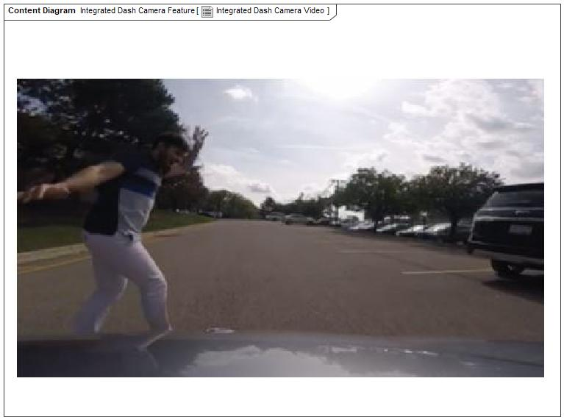

Figure 2: Integrated Dash Camera Video

## Feature Variants

No Feature Variants specified.

### Regions & Markets

No Feature Variants specified.

## Input Requirements/Documents

### Legal Requirements

* F_In_Req_001 : Compliance with FMVSS101
  + IDC display shall adhere to user visibility described in FMVSS 101.
* F_In_Req_002 : Compliance with FMVSS111
  + IDC shall adhere to rear view image regulation as described in FMVSS 111.

### Trustmark Requirements

No Trustmark Requirements specified.

### Industry Standards

* F_In_Req_003 : ISO 26262
  + IDC shall be developed according to Ford's Implementation of Functional Safety (IDC qualified as QM/new changes will require new analysis).

## Lessons Learned

No lessons learned specified.

## Assumptions

No Assumptions specified.

# Feature Context

## Feature Context Diagram

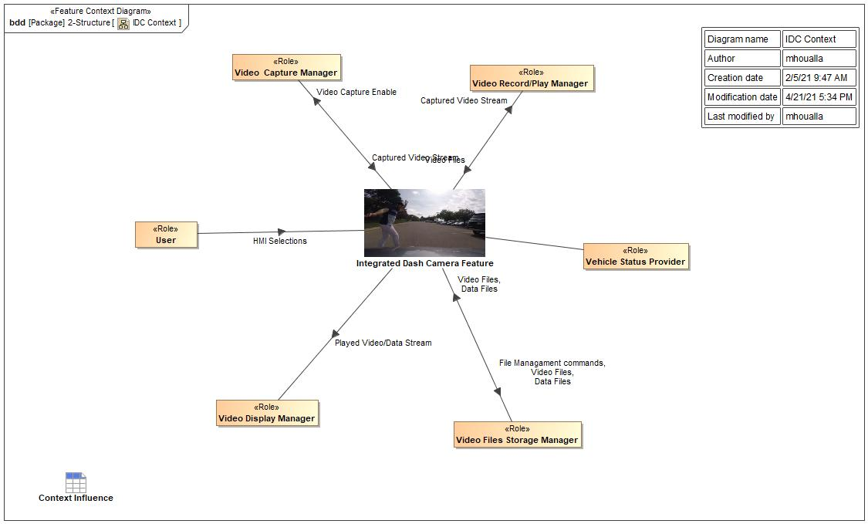

Figure 4: IDC Context

## List of Influences

|  |  |  |
| --- | --- | --- |
| **ID** | **External Entity** | **Influence Description** |
| Captured Video Stream | Integrated Dash Camera Feature To Video Record/Play Manager | The raw video stream captured by the external video capturing device. |
| Video Capture Manager To Integrated Dash Camera Feature | The raw video stream captured by the external video capturing device. |
| Data Files | Integrated Dash Camera Feature To Video Files Storage Manager | The data files stored along with the video files capturing data items like GPS, Vehicle Speed, Pedal Position, VIN etc. |
| Video Files Storage Manager To Integrated Dash Camera Feature | The data files stored along with the video files capturing data items like GPS, Vehicle Speed, Pedal Position, VIN etc. |
| File Managament commands | Integrated Dash Camera Feature To Video Files Storage Manager | The commands available in the Video File management tool, namely: Protect, Un-protect, Delete. |
| HMI Selections | User To Integrated Dash Camera Feature | This encompasses all the HMI selections the user can select. It could be Settings, or selecting videos to watch or Video Player commands or File Management commands |
| Played Video/Data Stream | Integrated Dash Camera Feature To Video Display Manager | This is the processed video stream with the data overlay that is sent to the vehicle display. |
| Video Capture Enable | Integrated Dash Camera Feature To Video Capture Manager | Video Capturing system Enable signal. |
| Video Files | Integrated Dash Camera Feature To Video Files Storage Manager | Video Files are the recorded video streams captured by the capturing devices. The files are recorded and stored to the memory device available. |
| Video Files Storage Manager To Integrated Dash Camera Feature | Video Files are the recorded video streams captured by the capturing devices. The files are recorded and stored to the memory device available. |
| Video Record/Play Manager To Integrated Dash Camera Feature | Video Files are the recorded video streams captured by the capturing devices. The files are recorded and stored to the memory device available. |

Table 9: List of Influences

# Feature Modeling

## Operation Modes and States

The purpose of this diagram is to describe and identify the high-level operational states of the feature.

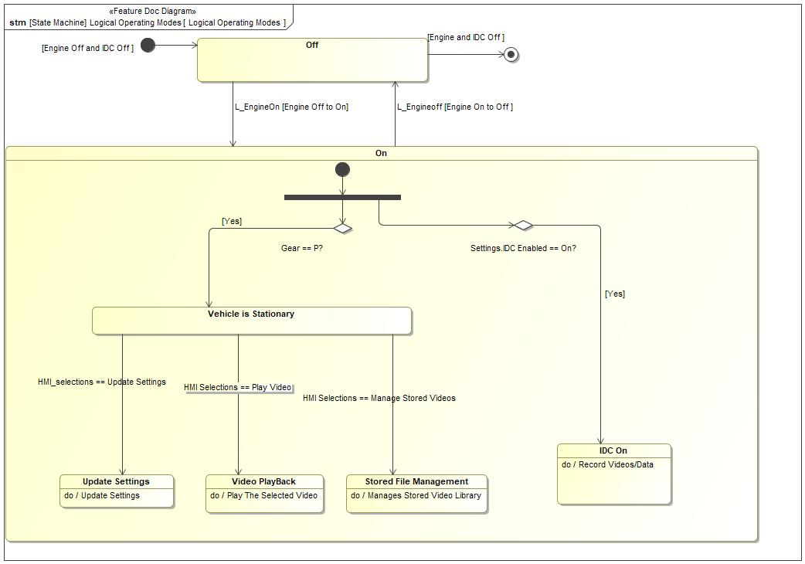

Figure 5: Logical Operating Modes

|  |  |  |
| --- | --- | --- |
| **State** | **Description** | **Requirements Reference** (optional) |
| IDC On | Driving Mode is the primary state provided to allow the driver to operate the vehicle. This includes accelerating, decelerating, cruising, sailing, and stopping.EDC feature will also be ON during start/stop.  Do behavior: Record Videos/Data |  |
| Off | This is the Vehicle Ignition Off State. |  |
| On | On  Entry behavior: Use Stored Settings  Do behavior: Update Settings |  |
| Stored File Management | This state is where the user can access the video files stored on the memory device and can perform these operations on:  1- Protect  2- Un-Protect  3- Delete  Do behavior: Manages Stored Video Library |  |
| Update Settings | This is the Update Settings state where user can update IDC settings.  Do behavior: Update Settings |  |
| Vehicle is Stationary | This is the state of Vehicle Stationary when Gear is in P positions. |  |
| Video PlayBack | Recorded video can be played back when vehicle is in Park mode.  Do behavior: Play The Selected Video |  |

Table 10: Operation Modes and States on Logical Operating Modes

|  |  |  |  |  |
| --- | --- | --- | --- | --- |
| **Transition ID** | **Source** | **Destination** | **Description** | **Requirements Reference**  (optional) |
| T1 | Vehicle is Stationary | Update Settings | Name: L_VehicleGearStatus==Park  Trigger signal: HMI_selections == Update Settings  SignalEvent HMI_selections == Update Settings |  |
| T2 | Gear == P? | Vehicle is Stationary | Guard: =Yes |  |
| T3 | Vehicle is Stationary | Video PlayBack | Name: HMI Selections == Play Video  Trigger signal: HMI Selections == Play Video  SignalEvent HMI Selections == Play Video |  |
| T4 |  |  | Name: Settings.IDC Enable == On? |  |
| T5 |  |  |  |  |
| T6 |  |  | Name: Initially Engine is in Off and EDC is Off  Documentation: Starting transition from NULL  Guard: Engine Off and IDC Off |  |
| T7 | Off | a | Name: Engine and EDC Off  Documentation: Final state  Guard: Engine and IDC Off |  |
| T8 |  |  | Name: EDC Off Engine On  Guard: =Engine On EDC Off |  |
| T9 | On | Off | Name: Engine On to Off and EDC Off  Documentation: transition from On to Off  Guard: =Engine On to Off  Trigger signal: L_Engineoff  SignalEvent L_Engineoff |  |
| T10 | Off | On | Guard: =Engine Off to On  Trigger signal: L_EngineOn  SignalEvent L_EngineOn |  |
| T11 | Settings.IDC Enabled == On? | IDC On | Guard: =Yes |  |
| T12 | Vehicle is Stationary | Stored File Management | Trigger signal: HMI Selections == Manage Stored Videos  SignalEvent HMI Selections == Manage Stored Videos |  |

Table 11: Transitions between Operation Modes and States on Logical Operating Modes

## Use Cases

### Use Case Diagram

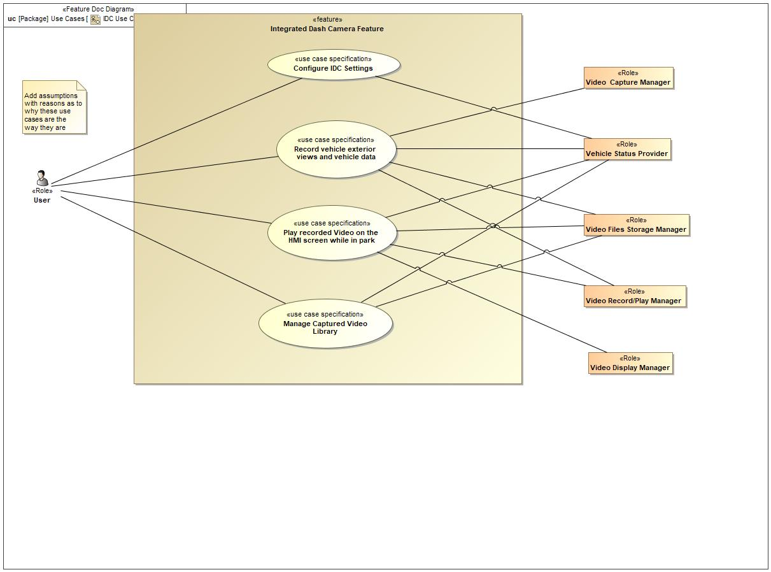

Figure 6: IDC Use Cases Diagram

### Actors

| **Actor** | **Description** |
| --- | --- |
| User | The "User" is the person who will use Integrated Dash Camera feature to record external videos and to watch/manage the stored video on the memory device. The user can be the driver or any person that interacts with the feature knowing that most IDC use cases will only be available when the vehicle is stationary. |
| Vehicle Status Provider | Vehicle Status Provider refers to the existing vehicle system that continuously provides various vehicle status information that could be readily used. IDC uses the following pieces of information provided by the Vehicle Status Provider:  1- Ignition State  2- Transmission Gear Position  3- Vehicle Vibration measurement. |
| Video Capture Manager | The Video Capture Manager is the vehicle system responsible for capturing vehicle external view videos while ignition is on. |
| Video Display Manager | The video display manager is responsible for displaying the played back video files onto the vehicle display. |
| Video Files Storage Manager | Video File Storage manager is the vehicle system responsible for storing the captured video files on a memory device and managing the storage. |
| Video Record/Play Manager | The Video Record/Play manager is the vehicle system responsible for recording the captured video and data streams to video files per the specified settings. The same system allows the user to retrieve the recorded files from the memory device and play them. |

Table 12: List of Actors

### Use Case Descriptions

Configure IDC Settings

|  |  |  |
| --- | --- | --- |
| **Actors** | Primary | User |
| Secondary | Vehicle Status Provider |
| **Subject** |  | Integrated Dash Camera Feature |
| **Description** |  |  |
| **Preconditions** | PreC1 | Ignition should be Run/Start. |
| PreC2 | Vehicle should be in park mode |
| **Triggers** | T1 | User / HMI |
| **Main Flow Description** |  | User is able to configure the following EDC files generation settings:  1- Video Length,  2- Video Resolution,  3- GSensor,  4- GPS,  5- Vehicle Speed,  6- Pedal Position |
| **Main Flow** | M1 | 1- User Select Settings |
| M2 | 2- IDC checks for Igniion On and Gear in P |
| M3 | 3- If met, IDC retrieves the saves Settings, if not found, it uses the Default settings |
| M4 | 4- User is allowed to update the Settings |
| **Alternative Flow Description** |  | N/A |

Record vehicle exterior views and vehicle data

|  |  |  |
| --- | --- | --- |
| **Actors** | Primary | User |
| Secondary | Vehicle Status Provider |
| Secondary | Video Capturer |
| Secondary | Video Recorder/Player |
| Secondary | Video Files Storage Manager |
| **Subject** |  | Integrated Dash Camera Feature |
| **Description** |  |  |
| **Preconditions** | PreC1 | Ignition should be Run/Start. |
| PreC2 | Infotainment system should be turned on |
| PreC3 | Memory device should be available. |
| **Triggers** | T1 | User / HMI |
| **Main Flow Description** |  | Successfuly records the selected cameras views, add the selected data and stored the files on the mass media selected |
| **Main Flow** | M1 | 1- User Turn Ignition On |
| M2 | 2- IDC checks that Ignition is on, if so it checks if Recording is enabled in Settings |
| M3 | 3- If Recording is Enabled, IDC starts recording by enabling Video Capture Manager to capture video |
| M4 | 4- The Captured Video/Data is sent to the Video Record/Play manager to be recorded into a file |
| M5 | 5- The recorded files are stored by the Storage Manager. |

Play recorded Video on the HMI screen while in park

|  |  |  |
| --- | --- | --- |
| **Actors** | Primary | User |
| Secondary | Vehicle Status Provider |
| Secondary | Video Display Manager |
| Secondary | Video Files Storage Manager |
| Secondary | Video Recorder/Player |
| **Subject** |  | Integrated Dash Camera Feature |
| **Description** |  | User wants to play back recorded video in sync display during any incident if customer wants to play back video on sync screen |
| **Preconditions** | PreC1 | Ignition should be Run/Start. |
| PreC2 | Memory device should be available. |
| PreC3 | Vehicle should be in park mode |
| **Triggers** | T1 | User / HMI |
| **Main Flow Description** |  | User can play back the USB stored video files on the vehicle display |
| **Main Flow** | M1 | 1- User Select the Video Play opiton |
| M2 | 2- IDC checks for Ignition On and Gear in P |
| M3 | 3- If met, IDC request the stored files list from the file storage manager |
| M4 | 4- IDC display the list received from the file storage manager. |
| M5 | 5- User selects a video to watch from the list |
| M6 | 6- IDC sends the Selected video index to the Video Record Play manager |
| M7 | 7- Video Record and Play plays the video and sends the video stream to IDC. |
| M8 | 8- IDC sends the video stram to be displayed |
| M9 | 9- User can select any of the video player function(Stop. Pause, Resume, Play) |
| M10 | 10- IDC receives the selected command and send the appropriate command to the Video Record and Play |
| M11 | <undefined> |
| **Alternative Flow Steps** | A1 | User can use a computer or tv to watch the videos. |
| **Exceptional Flow Steps** | E1 | Memory is not available in the device |
| E2 | User does not free up space in the storage device |
| E3 | Save not successful, captured video is not stored or protected |
| **Postconditions** | PostC1 | User can select the video which he wants to review |
| PostC2 | Video can be played back in Sync screen |

Manage Captured Video Library

|  |  |  |
| --- | --- | --- |
| **Actors** | Primary | User |
| Secondary | Video Files Storage Manager |
| Secondary | Vehicle Status Provider |
| **Subject** |  | Integrated Dash Camera Feature |
| **Description** |  | The Enhanced Dash Camera feature shall inform the driver feature status recording, standby, which cameras are selected to be recording |
| **Preconditions** | PreC1 | Ignition should be run/Start |
| PreC2 | Transmission In Park |
| **Triggers** | T1 | User Select Video Library Management |
| **Main Flow Description** |  | User can list the stored videos on the memory device and perform the following functions:  1- Protect/Unprotect  2- Delete |
| **Main Flow** | M1 | 1- User Select Manage Library option |
| M2 | 2- IDC checks for Ignition is on and Gear position is P. |
| M3 | 3- If they are, IDC request the stored video list from the video storage manager |
| M4 | 4- IDC receives the list and displays it |
| M5 | 5- User selects a file from the list to perform library management |
| M6 | 6- User select the desired library function to perform on the file (Delete, Protect, Unprotect) |
| M7 | 7- IDC sends the respective command to the file storage manager to accopmlish the request. |
| **Alternative Flow Description** |  | User can use a computer or tv to do file management on the videos.. |
| **Alternative Flow Steps** | A1 | 1- .... list steps |
| A2 | <undefined> |
| **Exceptional Flow Steps** | E1 | Memory is not available in the storage device |
| E2 | User does not free up space in the storage device |
| E3 | Save not successful, captured video is not stored or protected |
| **Postconditions** | PostC1 | User can understand the status of feature like recording,standby,which camera are in use for recording |

## Driving and Operation Scenarios

Sensor Reaches Threshold while driving

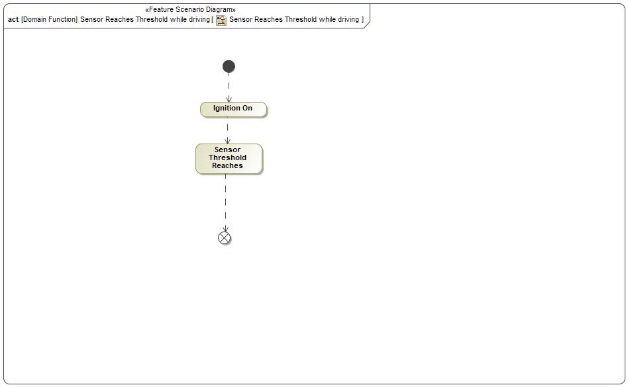

|  |  |
| --- | --- |
| **Flow of Actions** | |
| 1 | Ignition On |
| 2 | Sensor Threshold Reaches |

conditions for IDC activation

Description of the scenario in the Documentation field on the Feature Scenario Diagram.

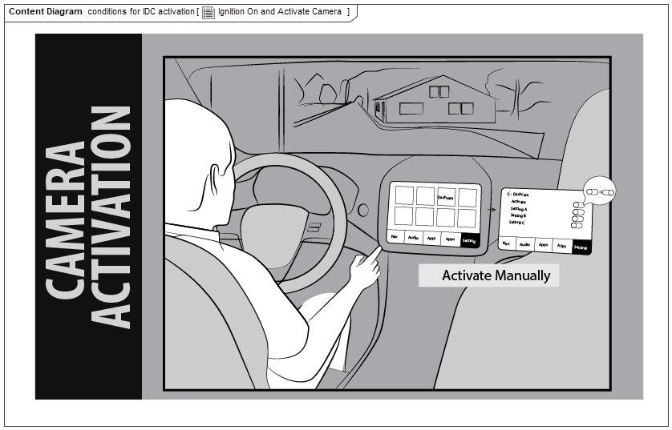

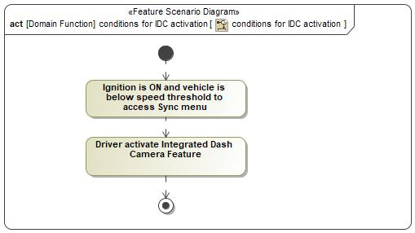

|  |  |
| --- | --- |
| **Flow of Actions** | |
| 1 | Ignition is ON and vehicle is below speed threshold to access Sync menu |
| 2 | Driver activate Integrated Dash Camera Feature |

conditions for Video Play back

Condition for video play back on Sync Screen

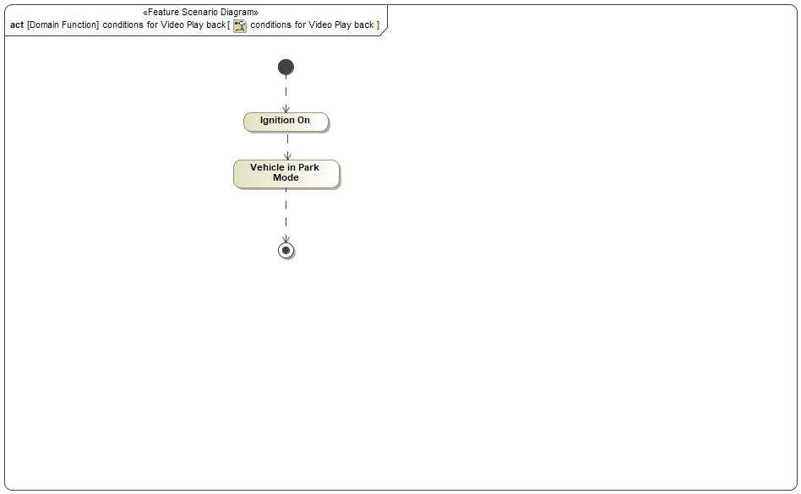

|  |  |
| --- | --- |
| **Flow of Actions** | |
| 1 | Ignition On |
| 2 | Vehicle in Park Mode |

## Decision Tables

*Not supported by MagicDraw report generation.*

# Feature Requirements

## Functional Requirements

F_IF_001 Video and Vehicle Data Record on Command

IDC shall record video and VEHICLE DATA once IGN is ON.

|  |  |  |  |  |  |  |  |
| --- | --- | --- | --- | --- | --- | --- | --- |
| Requirement ID: F_IF_001 | | | | | | | |
| **Rationale** | The feature activation requirements beyond the setting is that the IGN is ON/RUN. | | | | | | |
| **Acceptance Criteria** | Core Team Agreement | | | | | | |
| **Notes** |  | | | | | | |
| **Source** | NA | | | | | **Owner** | Feature Owner |
| **Source Req.** |  | | | | | **V&V Method** | Technical Design Review and Software Design Review |
| **Type** | Ideal Function | | | **Priority** | 1 - High | **Status** | In-Progress |
| [Req. Template](http://wiki.ford.com/display/RequirementsEngineering/Requirements+Attributes) Version | | 6.0 | End of Requirement | | | | |

F_IF_002 Video Playback on While Parked

IDC shall allow PLAYBACK on HMI only when the vehicle is in PARK.

|  |  |  |  |  |  |  |  |
| --- | --- | --- | --- | --- | --- | --- | --- |
| Requirement ID: F_IF_002 | | | | | | | |
| **Rationale** | The feature will not allow distractions such as video playback while driving. | | | | | | |
| **Acceptance Criteria** | Core Team Agreement | | | | | | |
| **Notes** |  | | | | | | |
| **Source** | NA | | | | | **Owner** | Feature Owner |
| **Source Req.** |  | | | | | **V&V Method** | Technical Design Review and Software Design Review |
| **Type** | Ideal Function | | | **Priority** |  | **Status** | In-Progress |
| [Req. Template](http://wiki.ford.com/display/RequirementsEngineering/Requirements+Attributes) Version | | 6.0 | End of Requirement | | | | |

F_IF_003 Inform the Driver of Recording Status

IDC shall inform the user of RECORDING STATUS.

|  |  |  |  |  |  |  |  |
| --- | --- | --- | --- | --- | --- | --- | --- |
| Requirement ID: F_IF_003 | | | | | | | |
| **Rationale** | The feature needs to convey the current status of the feature to the user. | | | | | | |
| **Acceptance Criteria** | Core Team Agreement | | | | | | |
| **Notes** |  | | | | | | |
| **Source** | NA | | | | | **Owner** | Feature Owner |
| **Source Req.** |  | | | | | **V&V Method** | Technical Design Review and Software Design Review |
| **Type** | Ideal Function | | | **Priority** |  | **Status** | In-Progress |
| [Req. Template](http://wiki.ford.com/display/RequirementsEngineering/Requirements+Attributes) Version | | 6.0 | End of Requirement | | | | |

F_IF_004 Inform the Driver of Recording Memory Status

IDC shall inform the user of available memory status.

|  |  |  |  |  |  |  |  |
| --- | --- | --- | --- | --- | --- | --- | --- |
| Requirement ID: F_IF_004 | | | | | | | |
| **Rationale** | The feature needs to inform the driver of the status of the memory on the storage device. | | | | | | |
| **Acceptance Criteria** | Core Team Agreement | | | | | | |
| **Notes** |  | | | | | | |
| **Source** | NA | | | | | **Owner** | Feature Owner |
| **Source Req.** |  | | | | | **V&V Method** | Technical Design Review and Software Design Review |
| **Type** | Ideal Function | | | **Priority** |  | **Status** | In-Progress |
| [Req. Template](http://wiki.ford.com/display/RequirementsEngineering/Requirements+Attributes) Version | | 6.0 | End of Requirement | | | | |

F_IF_005 Recorded Files to READ ONLY on Command

IDC shall allow user to select option to flag file as READ ONLY.

|  |  |  |  |  |  |  |  |
| --- | --- | --- | --- | --- | --- | --- | --- |
| Requirement ID: F_IF_005 | | | | | | | |
| **Rationale** | The user needs to be able to toggle the read-only status on a file via the saved videos menu. | | | | | | |
| **Acceptance Criteria** | Core Team Agreement | | | | | | |
| **Notes** |  | | | | | | |
| **Source** | NA | | | | | **Owner** | Feature Owner |
| **Source Req.** |  | | | | | **V&V Method** | Technical Design Review and Software Design Review |
| **Type** | Ideal Function | | | **Priority** |  | **Status** | In-Progress |
| [Req. Template](http://wiki.ford.com/display/RequirementsEngineering/Requirements+Attributes) Version | | 6.0 | End of Requirement | | | | |

F_IF_006 Recorded Files to READ ONLY Based on Sensor Exceeding user Threshold Settings

IDC shall flag files to READ ONLY based on sensor exceeding user threshold settings.

|  |  |  |  |  |  |  |  |
| --- | --- | --- | --- | --- | --- | --- | --- |
| Requirement ID: F_IF_006 | | | | | | | |
| **Rationale** | The feature needs to automatically change the current file being recorded to read-only should the user threshold settings be exceeded. | | | | | | |
| **Acceptance Criteria** | Core Team Agreement | | | | | | |
| **Notes** |  | | | | | | |
| **Source** | NA | | | | | **Owner** | Feature Owner |
| **Source Req.** |  | | | | | **V&V Method** | Technical Design Review and Software Design Review |
| **Type** | Ideal Function | | | **Priority** |  | **Status** | In-Progress |
| [Req. Template](http://wiki.ford.com/display/RequirementsEngineering/Requirements+Attributes) Version | | 6.0 | End of Requirement | | | | |

F_IF_007 Set Vehicle Data Recording Settings

IDC shall allow user the option to select vehicle data for IDC recording.

|  |  |  |  |  |  |  |  |
| --- | --- | --- | --- | --- | --- | --- | --- |
| Requirement ID: F_IF_007 | | | | | | | |
| **Rationale** | The feature needs to allow the user to select what vehicle data is recorded. | | | | | | |
| **Acceptance Criteria** | Core Team Agreement | | | | | | |
| **Notes** |  | | | | | | |
| **Source** | NA | | | | | **Owner** | Feature Owner |
| **Source Req.** |  | | | | | **V&V Method** | Technical Design Review and Software Design Review |
| **Type** | Ideal Function | | | **Priority** |  | **Status** | In-Progress |
| [Req. Template](http://wiki.ford.com/display/RequirementsEngineering/Requirements+Attributes) Version | | 6.0 | End of Requirement | | | | |

F_IF_008 Convey Recording Capability Status Through HMI

IDC shall inform user of feature RECORDING CAPABILITY STATUS.

|  |  |  |  |  |  |  |  |
| --- | --- | --- | --- | --- | --- | --- | --- |
| Requirement ID: F_IF_008 | | | | | | | |
| **Rationale** | The feature needs to communicate its ability to record. | | | | | | |
| **Acceptance Criteria** | Core Team Agreement | | | | | | |
| **Notes** |  | | | | | | |
| **Source** | NA | | | | | **Owner** | Feature Owner |
| **Source Req.** |  | | | | | **V&V Method** | Technical Design Review and Software Design Review |
| **Type** | Ideal Function | | | **Priority** |  | **Status** | In-Progress |
| [Req. Template](http://wiki.ford.com/display/RequirementsEngineering/Requirements+Attributes) Version | | 6.0 | End of Requirement | | | | |

F_IF_0010 Forward Facing Over-The-Hood Wide-Angle View

While active IDC shall record video from front exterior of the vehicle obtaining an over-the-hood wide-angle view.

|  |  |  |  |  |  |  |  |
| --- | --- | --- | --- | --- | --- | --- | --- |
| Requirement ID: F_IF_0010 | | | | | | | |
| **Rationale** | The feature goal is to record video from the vehicle exterior. | | | | | | |
| **Acceptance Criteria** | Core Team Agreement | | | | | | |
| **Notes** |  | | | | | | |
| **Source** | NA | | | | | **Owner** | Feature Owner |
| **Source Req.** |  | | | | | **V&V Method** | Technical Design Review and Software Design Review |
| **Type** | Ideal Function | | | **Priority** |  | **Status** | In-Progress |
| [Req. Template](http://wiki.ford.com/display/RequirementsEngineering/Requirements+Attributes) Version | | 6.0 | End of Requirement | | | | |

F_IF_0011 Video Playback When Selected by User

IDC shall play back recorded video on vehicle display when commanded by user.

|  |  |  |  |  |  |  |  |
| --- | --- | --- | --- | --- | --- | --- | --- |
| Requirement ID: F_IF_0011 | | | | | | | |
| **Rationale** | The feature needs to be able to playback video on demand by the user through HMI menu. | | | | | | |
| **Acceptance Criteria** | Core Team Agreement | | | | | | |
| **Notes** |  | | | | | | |
| **Source** | NA | | | | | **Owner** | Feature Owner |
| **Source Req.** |  | | | | | **V&V Method** | Technical Design Review and Software Design Review |
| **Type** | Ideal Function | | | **Priority** |  | **Status** | In-Progress |
| [Req. Template](http://wiki.ford.com/display/RequirementsEngineering/Requirements+Attributes) Version | | 6.0 | End of Requirement | | | | |

F_IF_0012 Convey Recording Status Through HMI

IDC shall inform user of FEATURE STATUS.

|  |  |  |  |  |  |  |  |
| --- | --- | --- | --- | --- | --- | --- | --- |
| Requirement ID: F_IF_0012 | | | | | | | |
| **Rationale** | The feature needs to communicate its status, ON/OFF, via HMI. | | | | | | |
| **Acceptance Criteria** | Core Team Agreement | | | | | | |
| **Notes** |  | | | | | | |
| **Source** | NA | | | | | **Owner** | Feature Owner |
| **Source Req.** |  | | | | | **V&V Method** | Technical Design Review and Software Design Review |
| **Type** | Ideal Function | | | **Priority** |  | **Status** | In-Progress |
| [Req. Template](http://wiki.ford.com/display/RequirementsEngineering/Requirements+Attributes) Version | | 6.0 | End of Requirement | | | | |

F_IF_0013 IDC Settings at Vehicle Wake-Up

IDC shall remember settings across ignition cycles.

|  |  |  |  |  |  |  |  |
| --- | --- | --- | --- | --- | --- | --- | --- |
| Requirement ID: F_IF_0013 | | | | | | | |
| **Rationale** | The feature needs to remember the state of the settings across ignition cycles so that it may resume from where it left off without customer intervention. | | | | | | |
| **Acceptance Criteria** | Core Team Agreement | | | | | | |
| **Notes** |  | | | | | | |
| **Source** | NA | | | | | **Owner** | Feature Owner |
| **Source Req.** |  | | | | | **V&V Method** | Technical Design Review and Software Design Review |
| **Type** | Ideal Function | | | **Priority** |  | **Status** | In-Progress |
| [Req. Template](http://wiki.ford.com/display/RequirementsEngineering/Requirements+Attributes) Version | | 6.0 | End of Requirement | | | | |

F_IF_0014 Detect Events

IDC shall receive feedback that events are detected.

|  |  |  |  |  |  |  |  |
| --- | --- | --- | --- | --- | --- | --- | --- |
| Requirement ID: F_IF_0014 | | | | | | | |
| **Rationale** |  | | | | | | |
| **Acceptance Criteria** | Core Team Agreement | | | | | | |
| **Notes** | The vibrations detected indicates some sort of accident with the vehicle. | | | | | | |
| **Source** | NA | | | | | **Owner** | Feature Owner |
| **Source Req.** |  | | | | | **V&V Method** | Technical Design Review and Software Design Review |
| **Type** | Ideal Function | | | **Priority** |  | **Status** | In-Progress |
| [Req. Template](http://wiki.ford.com/display/RequirementsEngineering/Requirements+Attributes) Version | | 6.0 | End of Requirement | | | | |

F_IF_0015 MP4 Video File Container

IDC video recording shall be saved in the MP4 container format.

|  |  |  |  |  |  |  |  |
| --- | --- | --- | --- | --- | --- | --- | --- |
| Requirement ID: F_IF_0015 | | | | | | | |
| **Rationale** | The feature requires the user to be able to easily play recorded videos on their own device. | | | | | | |
| **Acceptance Criteria** | Core Team Agreement | | | | | | |
| **Notes** |  | | | | | | |
| **Source** | NA | | | | | **Owner** | Feature Owner |
| **Source Req.** |  | | | | | **V&V Method** | Technical Design Review and Software Design Review |
| **Type** | Ideal Function | | | **Priority** |  | **Status** | In-Progress |
| [Req. Template](http://wiki.ford.com/display/RequirementsEngineering/Requirements+Attributes) Version | | 6.0 | End of Requirement | | | | |

F_IF_0016 Enable Recording

IDC shall allow user to enable and disable recording.

|  |  |  |  |  |  |  |  |
| --- | --- | --- | --- | --- | --- | --- | --- |
| Requirement ID: F_IF_0016 | | | | | | | |
| **Rationale** |  | | | | | | |
| **Acceptance Criteria** | Core Team Agreement | | | | | | |
| **Notes** |  | | | | | | |
| **Source** | NA | | | | | **Owner** | Feature Owner |
| **Source Req.** |  | | | | | **V&V Method** | Technical Design Review and Software Design Review |
| **Type** | Ideal Function | | | **Priority** |  | **Status** | In-Progress |
| [Req. Template](http://wiki.ford.com/display/RequirementsEngineering/Requirements+Attributes) Version | | 6.0 | End of Requirement | | | | |

### Error Handling

No Error Handling Requirements specified.

## Non-Functional Requirements

### Safety

*Not supported by MagicDraw report generation.*

### Security

Vehicle Data Encryption

IDC shall request vehicle data be encrypted during recording.

|  |  |  |  |  |  |  |  |
| --- | --- | --- | --- | --- | --- | --- | --- |
| Requirement ID: | | | | | | | |
| **Rationale** | To comply with cybersecurity requirements. | | | | | | |
| **Acceptance Criteria** | Vehicle data will only be accessable during invheicle playback. | | | | | | |
| **Notes** | This came as a result of TARA. | | | | | | |
| **Source** | NA | | | | | **Owner** | Malik Eteer |
| **Source Req.** |  | | | | | **V&V Method** | DV Testing |
| **Type** | Cybersecurity | | | **Priority** |  | **Status** | In-Progress |
| [Req. Template](http://wiki.ford.com/display/RequirementsEngineering/Requirements+Attributes) Version | | 6.0 | End of Requirement | | | | |

F_CSR_001 Recorder Service Command and Control

IDC command and control interactions with the video recorder service shall take place over an authenticated channel.

|  |  |  |  |  |  |  |  |
| --- | --- | --- | --- | --- | --- | --- | --- |
| Requirement ID: F_CSR_001 | | | | | | | |
| **Rationale** | To comply with cybersecurity requirements. | | | | | | |
| **Acceptance Criteria** | 1 - Packet captures of Ethernet data to Video Recorder will show TLS encryption. 2 - TLS version 1.2 or greater | | | | | | |
| **Notes** |  | | | | | | |
| **Source** | NA | | | | | **Owner** | Feature Owner |
| **Source Req.** |  | | | | | **V&V Method** | Technical Design Review and Software Design Review DV Testing |
| **Type** | Cybersecurity | | | **Priority** |  | **Status** | Approved |
| [Req. Template](http://wiki.ford.com/display/RequirementsEngineering/Requirements+Attributes) Version | | 6.0 | End of Requirement | | | | |

F_CSR_002 Camera System Isolation

IDC recorded information shall be used for IDC feature functionality only.

|  |  |  |  |  |  |  |  |
| --- | --- | --- | --- | --- | --- | --- | --- |
| Requirement ID: F_CSR_002 | | | | | | | |
| **Rationale** | To prevent feature creep as well as to maintain the QM functional safety level by preventing features of higher functional safety level from tying their functionality to IDC. | | | | | | |
| **Acceptance Criteria** | No other systems are using Enhanced Dash Camera System data for inputs to vehicle functionality. | | | | | | |
| **Notes** | IDC will not be used to influence any actions to be taken by other vehicle systems as part of the cyber threat model. For example, it is assumed this camera system shall not be used for any ADAS functions. | | | | | | |
| **Source** | NA | | | | | **Owner** | Feature Owner |
| **Source Req.** |  | | | | | **V&V Method** | Technical Design Review and Software Design Review DV Testing |
| **Type** | Cybersecurity | | | **Priority** | 1 - High | **Status** | Approved |
| [Req. Template](http://wiki.ford.com/display/RequirementsEngineering/Requirements+Attributes) Version | | 6.0 | End of Requirement | | | | |

F_CSR_003 Enhanced Dash Options Disabled in Valet Mode

When vehicle is in VALET MODE, IDC shall block unauthorized viewing or deletion of dash camera videos.

|  |  |  |  |  |  |  |  |
| --- | --- | --- | --- | --- | --- | --- | --- |
| Requirement ID: F_CSR_003 | | | | | | | |
| **Rationale** | To prevent the Valet from accessing the video and recorded data in vehicle. | | | | | | |
| **Acceptance Criteria** | The Enhanced Dash Feature Interface is not accessible by the user while in Valet Mode. | | | | | | |
| **Notes** |  | | | | | | |
| **Source** | NA | | | | | **Owner** | Feature Owner |
| **Source Req.** |  | | | | | **V&V Method** | Technical Design Review and Software Design Review DV Testing |
| **Type** | Cybersecurity | | | **Priority** | 1 | **Status** | Approved |
| [Req. Template](http://wiki.ford.com/display/RequirementsEngineering/Requirements+Attributes) Version | | 6.0 | End of Requirement | | | | |

### Reliability

No Reliability Requirements specified.

### Performance

No Performance Requirements specified.

## HMI Requirements

F_HMI_001 Camera Settings

IDC shall provide means for the user to select camera settings.

|  |  |  |  |  |  |  |  |
| --- | --- | --- | --- | --- | --- | --- | --- |
| Requirement ID: F_HMI_001 | | | | | | | |
| **Rationale** | User needs to be able to select the settings via HMI. | | | | | | |
| **Acceptance Criteria** | Fore Core Team Agreement | | | | | | |
| **Notes** |  | | | | | | |
| **Source** | NA | | | | | **Owner** | Feature Owner |
| **Source Req.** |  | | | | | **V&V Method** | Technical Design Review and Software Design Review |
| **Type** | HMI Requirement | | | **Priority** |  | **Status** | In-Progress |
| [Req. Template](http://wiki.ford.com/display/RequirementsEngineering/Requirements+Attributes) Version | | 6.0 | End of Requirement | | | | |

F_HMI_002 Camera Activation

IDC shall provide means to activate and deactivate the feature functionality.

|  |  |  |  |  |  |  |  |
| --- | --- | --- | --- | --- | --- | --- | --- |
| Requirement ID: F_HMI_002 | | | | | | | |
| **Rationale** | The user needs to be able to activate and deactivate the feature via a button of some sort. | | | | | | |
| **Acceptance Criteria** | Fore Core Team Agreement | | | | | | |
| **Notes** |  | | | | | | |
| **Source** | NA | | | | | **Owner** | Feature Owner |
| **Source Req.** |  | | | | | **V&V Method** | HMI Interface test aligned with Wireframe |
| **Type** | HMI Requirement | | | **Priority** |  | **Status** | In-Progress |
| [Req. Template](http://wiki.ford.com/display/RequirementsEngineering/Requirements+Attributes) Version | | 6.0 | End of Requirement | | | | |

F_HMI_003 Permission to Record

IDC shall provide means for the user to accept or reject the recording of videos.

|  |  |  |  |  |  |  |  |
| --- | --- | --- | --- | --- | --- | --- | --- |
| Requirement ID: F_HMI_003 | | | | | | | |
| **Rationale** | Permission is required to record video. | | | | | | |
| **Acceptance Criteria** | Fore Core Team Agreement | | | | | | |
| **Notes** |  | | | | | | |
| **Source** | NA | | | | | **Owner** | Feature Owner |
| **Source Req.** |  | | | | | **V&V Method** | Technical Design Review and Software Design Review |
| **Type** | HMI Requirement | | | **Priority** |  | **Status** | In-Progress |
| [Req. Template](http://wiki.ford.com/display/RequirementsEngineering/Requirements+Attributes) Version | | 6.0 | End of Requirement | | | | |

F_HMI_004 Play, ~~Save~~ Protect or Delete

IDC shall provide means for the user to PLAY, ~~SAVE~~ Protect/Unprotect, or DELETE videos saved to memory.

|  |  |  |  |  |  |  |  |
| --- | --- | --- | --- | --- | --- | --- | --- |
| Requirement ID: F_HMI_004 | | | | | | | |
| **Rationale** | The user needs access to library controls of their saved videos in vehicle. | | | | | | |
| **Acceptance Criteria** | Fore Core Team Agreement | | | | | | |
| **Notes** |  | | | | | | |
| **Source** | NA | | | | | **Owner** | Feature Owner |
| **Source Req.** |  | | | | | **V&V Method** | Technical Design Review and Software Design Review |
| **Type** | HMI Requirement | | | **Priority** |  | **Status** | In-Progress |
| [Req. Template](http://wiki.ford.com/display/RequirementsEngineering/Requirements+Attributes) Version | | 6.0 | End of Requirement | | | | |

F_HMI_005 Playback on HMI Display

IDC shall provide means for the user to PLAYBACK video and vehicle data overlay while in park.

|  |  |  |  |  |  |  |  |
| --- | --- | --- | --- | --- | --- | --- | --- |
| Requirement ID: F_HMI_005 | | | | | | | |
| **Rationale** | The feature requires the ability to playback video in vehicle. | | | | | | |
| **Acceptance Criteria** | Fore Core Team Agreement | | | | | | |
| **Notes** |  | | | | | | |
| **Source** | NA | | | | | **Owner** | Feature Owner |
| **Source Req.** |  | | | | | **V&V Method** | Technical Design Review and Software Design Review |
| **Type** | HMI Requirement | | | **Priority** |  | **Status** | In-Progress |
| [Req. Template](http://wiki.ford.com/display/RequirementsEngineering/Requirements+Attributes) Version | | 6.0 | End of Requirement | | | | |

F_HMI_006 Vehicle Data ~~convert files to~~ toggle read only during playback

IDC shall provide means for the user to ~~flag files to READ ONLY during PLAYBACK.~~ Toggle read-only during PLAYBACK

|  |  |  |  |  |  |  |  |
| --- | --- | --- | --- | --- | --- | --- | --- |
| Requirement ID: F_HMI_006 | | | | | | | |
| **Rationale** | The user should be able to toggle the read-only status on a file during playback for ease of access. | | | | | | |
| **Acceptance Criteria** | Fore Core Team Agreement | | | | | | |
| **Notes** |  | | | | | | |
| **Source** | NA | | | | | **Owner** | Feature Owner |
| **Source Req.** |  | | | | | **V&V Method** | Technical Design Review and Software Design Review |
| **Type** | HMI Requirement | | | **Priority** |  | **Status** | In-Progress |
| [Req. Template](http://wiki.ford.com/display/RequirementsEngineering/Requirements+Attributes) Version | | 6.0 | End of Requirement | | | | |

F_HMI_007 Vehicle Data convert files to read only on demand

IDC shall have HMI quick access to convert files to READ ONLY.

|  |  |  |  |  |  |  |  |
| --- | --- | --- | --- | --- | --- | --- | --- |
| Requirement ID: F_HMI_007 | | | | | | | |
| **Rationale** | The user should be able to mark a file as read-only while driving with minimum distraction and effort. This is accomplished via an HMI quick access, an icon soft press for example. | | | | | | |
| **Acceptance Criteria** | Fore Core Team Agreement | | | | | | |
| **Notes** |  | | | | | | |
| **Source** | NA | | | | | **Owner** | Feature Owner |
| **Source Req.** |  | | | | | **V&V Method** | Technical Design Review and Software Design Review |
| **Type** | HMI Requirement | | | **Priority** |  | **Status** | In-Progress |
| [Req. Template](http://wiki.ford.com/display/RequirementsEngineering/Requirements+Attributes) Version | | 6.0 | End of Requirement | | | | |

F_HMI_008 Vehicle Data Settings

IDC shall provide means for the user to select vehicle data to be recorded with video.

|  |  |  |  |  |  |  |  |
| --- | --- | --- | --- | --- | --- | --- | --- |
| Requirement ID: F_HMI_008 | | | | | | | |
| **Rationale** | The user should be able to select what vehicle data they want to record alongside the video. | | | | | | |
| **Acceptance Criteria** | Fore Core Team Agreement | | | | | | |
| **Notes** |  | | | | | | |
| **Source** | NA | | | | | **Owner** | Feature Owner |
| **Source Req.** |  | | | | | **V&V Method** | Technical Design Review and Software Design Review |
| **Type** | HMI Requirement | | | **Priority** |  | **Status** | In-Progress |
| [Req. Template](http://wiki.ford.com/display/RequirementsEngineering/Requirements+Attributes) Version | | 6.0 | End of Requirement | | | | |

F_HMI_009 Inform the Driver of Recording capability

IDC shall inform user of RECORDING CAPABILITY STATUS.

|  |  |  |  |  |  |  |  |
| --- | --- | --- | --- | --- | --- | --- | --- |
| Requirement ID: F_HMI_009 | | | | | | | |
| **Rationale** | The feature needs to communicate its ability to record to the customer to convey status. | | | | | | |
| **Acceptance Criteria** | Fore Core Team Agreement | | | | | | |
| **Notes** |  | | | | | | |
| **Source** | NA | | | | | **Owner** | Feature Owner |
| **Source Req.** |  | | | | | **V&V Method** | Technical Design Review and Software Design Review |
| **Type** | HMI Requirement | | | **Priority** |  | **Status** | In-Progress |
| [Req. Template](http://wiki.ford.com/display/RequirementsEngineering/Requirements+Attributes) Version | | 6.0 | End of Requirement | | | | |

F_HMI_0011 HMI IDC Activation

NEED TEXT HERE

|  |  |  |  |  |  |  |  |
| --- | --- | --- | --- | --- | --- | --- | --- |
| Requirement ID: F_HMI_0011 | | | | | | | |
| **Rationale** |  | | | | | | |
| **Acceptance Criteria** | Fore Core Team Agreement | | | | | | |
| **Notes** |  | | | | | | |
| **Source** | NA | | | | | **Owner** | Feature Owner |
| **Source Req.** |  | | | | | **V&V Method** | Technical Design Review and Software Design Review |
| **Type** | HMI Requirement | | | **Priority** |  | **Status** | In-Progress |
| [Req. Template](http://wiki.ford.com/display/RequirementsEngineering/Requirements+Attributes) Version | | 6.0 | End of Requirement | | | | |

F_HMI_0012 Protect, Unprotect, Delete

IDC shall provide means for the user to PROTECT, UNPROTECT, or DELETE a selected video.

|  |  |  |  |  |  |  |  |
| --- | --- | --- | --- | --- | --- | --- | --- |
| Requirement ID: F_HMI_0012 | | | | | | | |
| **Rationale** |  | | | | | | |
| **Acceptance Criteria** | Fore Core Team Agreement | | | | | | |
| **Notes** |  | | | | | | |
| **Source** | NA | | | | | **Owner** | Feature Owner |
| **Source Req.** |  | | | | | **V&V Method** | Technical Design Review and Software Design Review |
| **Type** | HMI Requirement | | | **Priority** |  | **Status** | In-Progress |
| [Req. Template](http://wiki.ford.com/display/RequirementsEngineering/Requirements+Attributes) Version | | 6.0 | End of Requirement | | | | |

F_HMI_0013 HMI Save Updated Setting

NEED TEXT HERE

|  |  |  |  |  |  |  |  |
| --- | --- | --- | --- | --- | --- | --- | --- |
| Requirement ID: F_HMI_0013 | | | | | | | |
| **Rationale** |  | | | | | | |
| **Acceptance Criteria** | Fore Core Team Agreement | | | | | | |
| **Notes** |  | | | | | | |
| **Source** | NA | | | | | **Owner** | Feature Owner |
| **Source Req.** |  | | | | | **V&V Method** | Technical Design Review and Software Design Review |
| **Type** | HMI Requirement | | | **Priority** |  | **Status** | In-Progress |
| [Req. Template](http://wiki.ford.com/display/RequirementsEngineering/Requirements+Attributes) Version | | 6.0 | End of Requirement | | | | |

## Other Requirements

### Design Requirements

*Not supported by MagicDraw report generation.*

### Manufacturing Requirements

No Manufacturing Requirements specified.

### Service Requirements

No Service Requirements specified.

#### **Cloud Connectivity Data Analytics Requirements**

### After Sales Requirements

No After Sales Requirements specified.

### Process Requirements

No Process Requirements specified.

### Uncategorized Requirements

F_HMI_0010 HMI IDC Activation

|  |  |  |  |  |  |  |  |
| --- | --- | --- | --- | --- | --- | --- | --- |
| Requirement ID: F_HMI_0010 | | | | | | | |
| **Rationale** |  | | | | | | |
| **Acceptance Criteria** |  | | | | | | |
| **Notes** |  | | | | | | |
| **Source** |  | | | | | **Owner** |  |
| **Source Req.** |  | | | | | **V&V Method** |  |
| **Type** |  | | | **Priority** |  | **Status** | In-Progress |
| [Req. Template](http://wiki.ford.com/display/RequirementsEngineering/Requirements+Attributes) Version | | 6.0 | End of Requirement | | | | |

# Functional Safety

## System Behaviors for HARA

|  |  |  |
| --- | --- | --- |
| **ID** | **Name** | **Description** |
|  | Deactivate Enhanced Dash Camera |  |
|  | Activate Enhanced Dash Camera |  |
|  | Report Feature Status |  |
|  | EDC Feature Playback |  |

Table 13: System Behaviors for HARA

## Functional Safety Assumptions

|  |  |  |
| --- | --- | --- |
| ID | Assumption | |
|  | **Name** | Assumption1 EDC is not part of any vehicle ADAS features |
| **Description** | EDC is a NON ADAS feature. Not linked with any ADAS features. |
| **Purpose** | This is user experience feature NON-DAT. This feature does not provide any inputs or feedback to the ADAS module. |
| **Category** | Vehicle |
| **Related Requirement IDs** |  |

Table 14: Functional Safety Assumptions

## Safety Goals

|  |  |  |  |  |
| --- | --- | --- | --- | --- |
| ID | Goal | | | |
|  | **Goal Name** | Prevent Hazard (Example) | | |
| **Description** |  | | |
| **Safety Goal Concept** | Safety Goal Concept:  Warning & Recovery Concept: | | |
| **ASIL** |  | **FTTI** |  |
| **Related FSR IDs** |  | | |

Table 15: Functional Safety Goals

## Functional Safety Requirements

### Safety Goal: Prevent Hazard (Example)

**Name:** Prevent Hazard (Example)

**Purpose:**

**Text:**

**ASIL:**

#### Safety Goal Concept

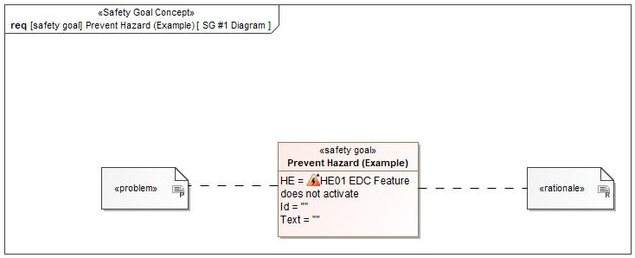

Figure 1: SG #1 Diagram – Prevent Hazard (Example)

*Note: The authoritative source for the Safety Goals is document “FFSD 02 Hazard Analysis* *and Risk Assessment”. The documentation of Safety Goals in this chapter (In the Argumentation for Safety Goal achievement) is for information purposes only.*

*The authoritative source for the Functional Safety Requirements is section 2.1.x.3: of this document. The documentation of Functional Safety Requirements in the following chapter (complete or summarised) is for information purposes only.*

#### Warning and Recovery Concept

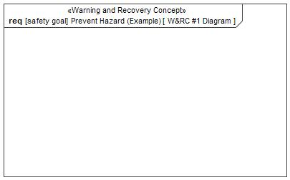

Figure 7: W&RC #1 Diagram – Prevent Hazard (Example)

### Derivation of Functional Safety Requirements on Assumptions

No Functional Safety Requirements tracing to Assumptions specified.

### ASIL Decomposition of Functional Safety Requirements

### Decomposition of Functional Safety Requirement

| Initial Safety Requirement | First FSR | |
| --- | --- | --- |
| Decomposition Rationale |  | |
| Method for Decomposition | A -> A(A) + QM(A) | |
| Functional Safety Requirement 1 after Decomposition | F-S-Req-ID |  |
| F-S-Req. Title | Monitor Function FSR |
| ASIL | A(A) |
| Rationale |  |
| Satisfied by | * IDC Controller |
| Functional Safety Requirement 2 after Decomposition | F-S-Req-ID |  |
| F-S-Req. Title | QM(A) |
| ASIL | Main Function FSR |
| Rationale |  |
| Satisfied by | * IDC Controller |
| Functional Safety Requirement for Independence | F-S-Req.-ID |  |
| F-S-Req. Title | Main and Monitor Independence |
| ASIL |  |
| Rationale |  |

# CyberSecurity

## Security Goals

|  |  |  |
| --- | --- | --- |
| ID | Goal | |
|  | **Goal Name** |  |
| **Description** |  |
| **CAL** |  |
| **Related CSR IDs** |  |
|  | **Goal Name** |  |
| **Description** |  |
| **CAL** |  |
| **Related CSR IDs** |  |
|  | **Goal Name** |  |
| **Description** |  |
| **CAL** |  |
| **Related CSR IDs** |  |

Table 18: Cybersecurity Goals

## Cybersecurity Requirements

# Architecture

## Functional Decomposition

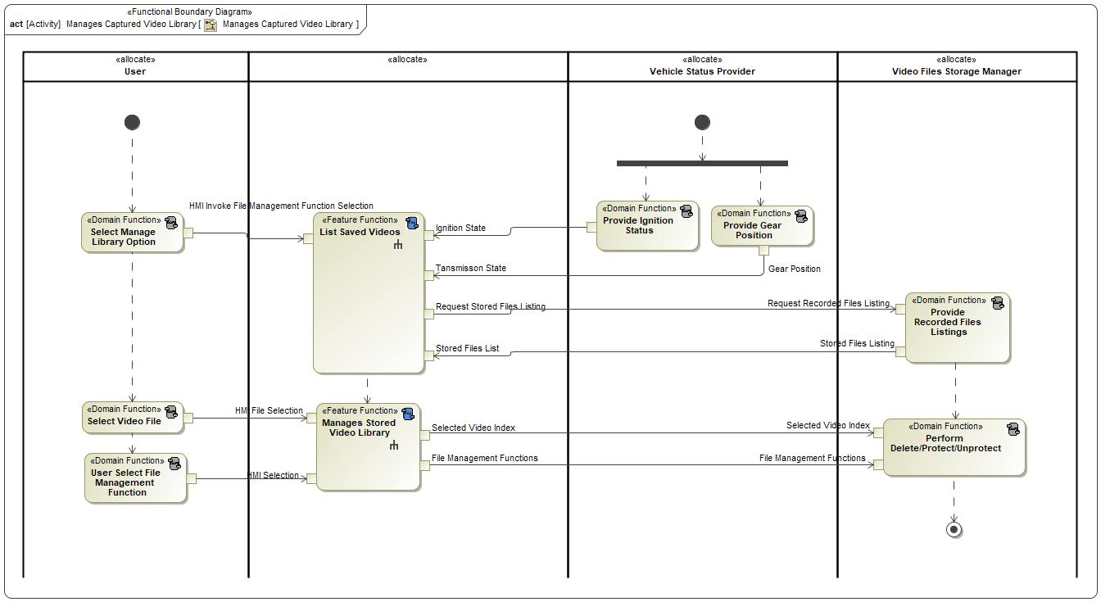

Figure 8: Manages Captured Video Library

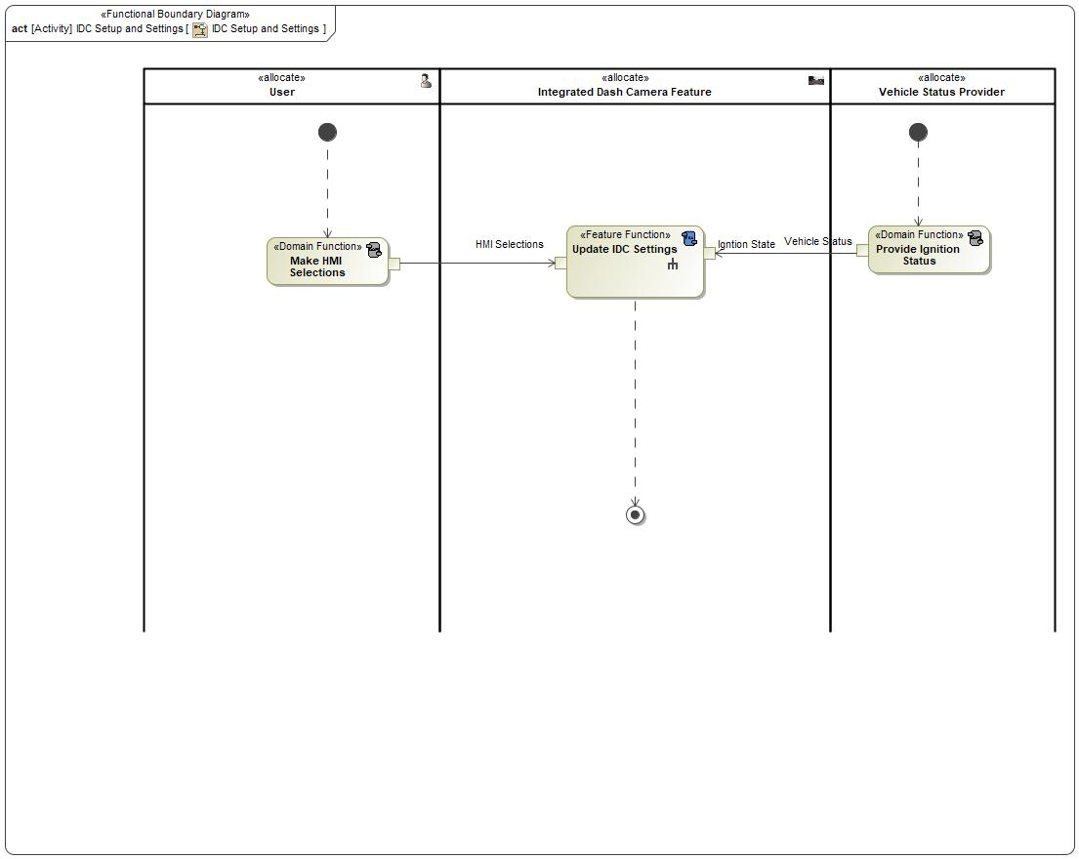

Figure 8: IDC Setup and Settings

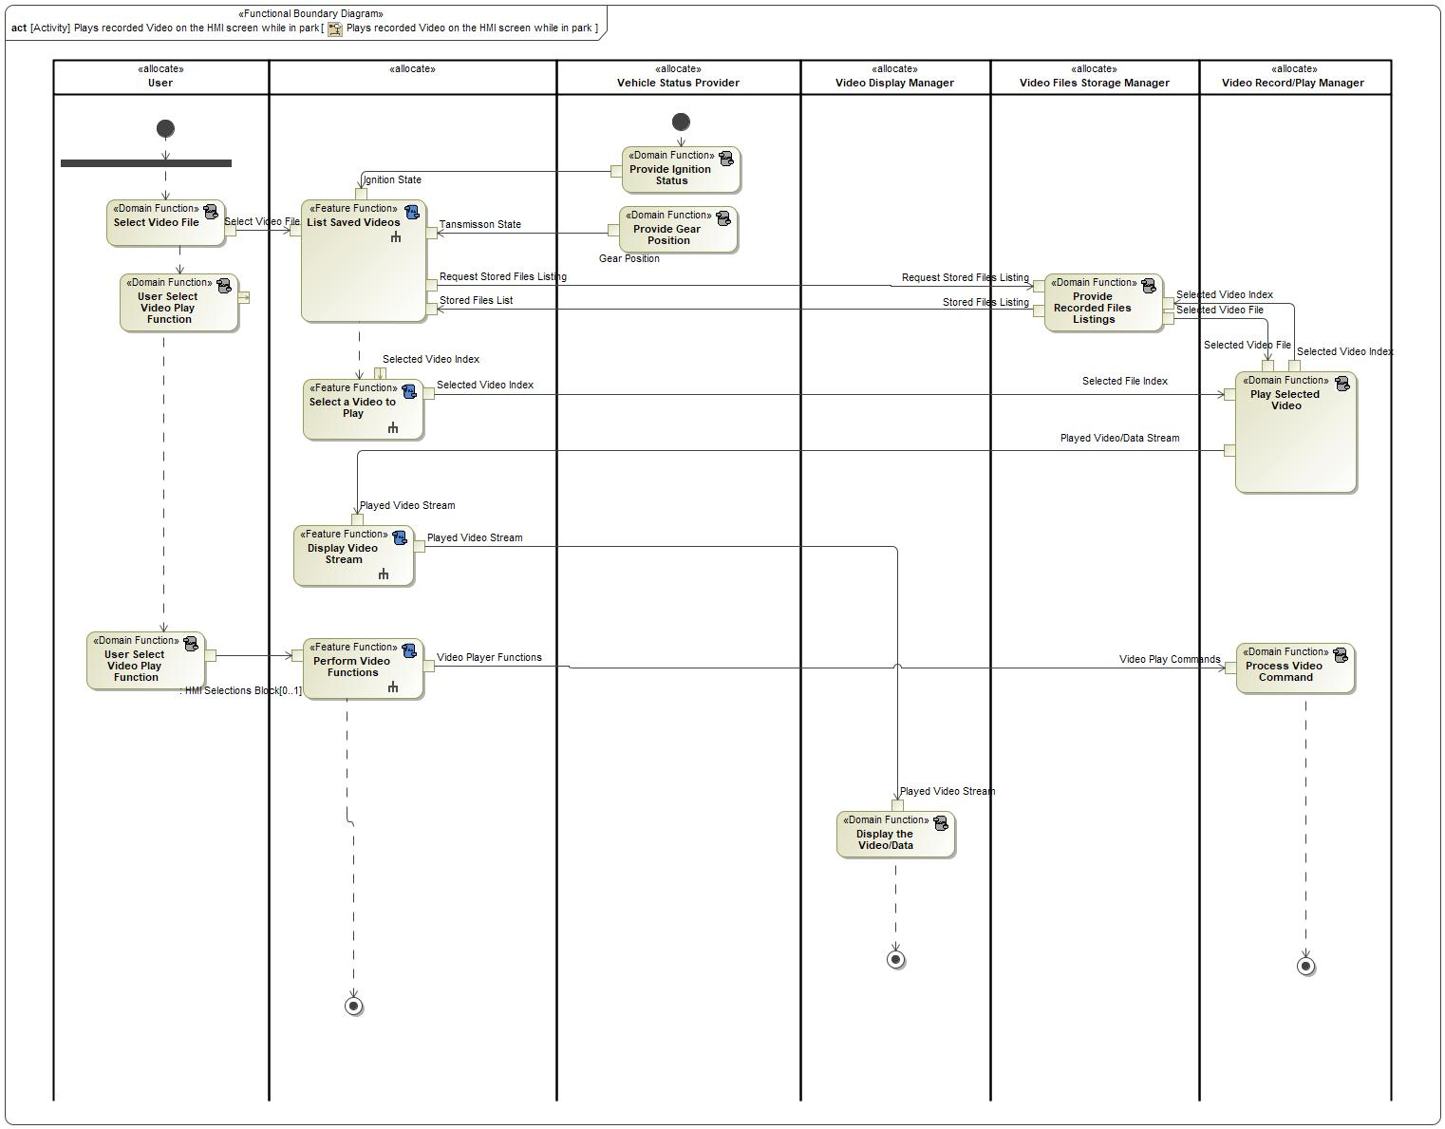

Figure 8: Plays recorded Video on the HMI screen while in park

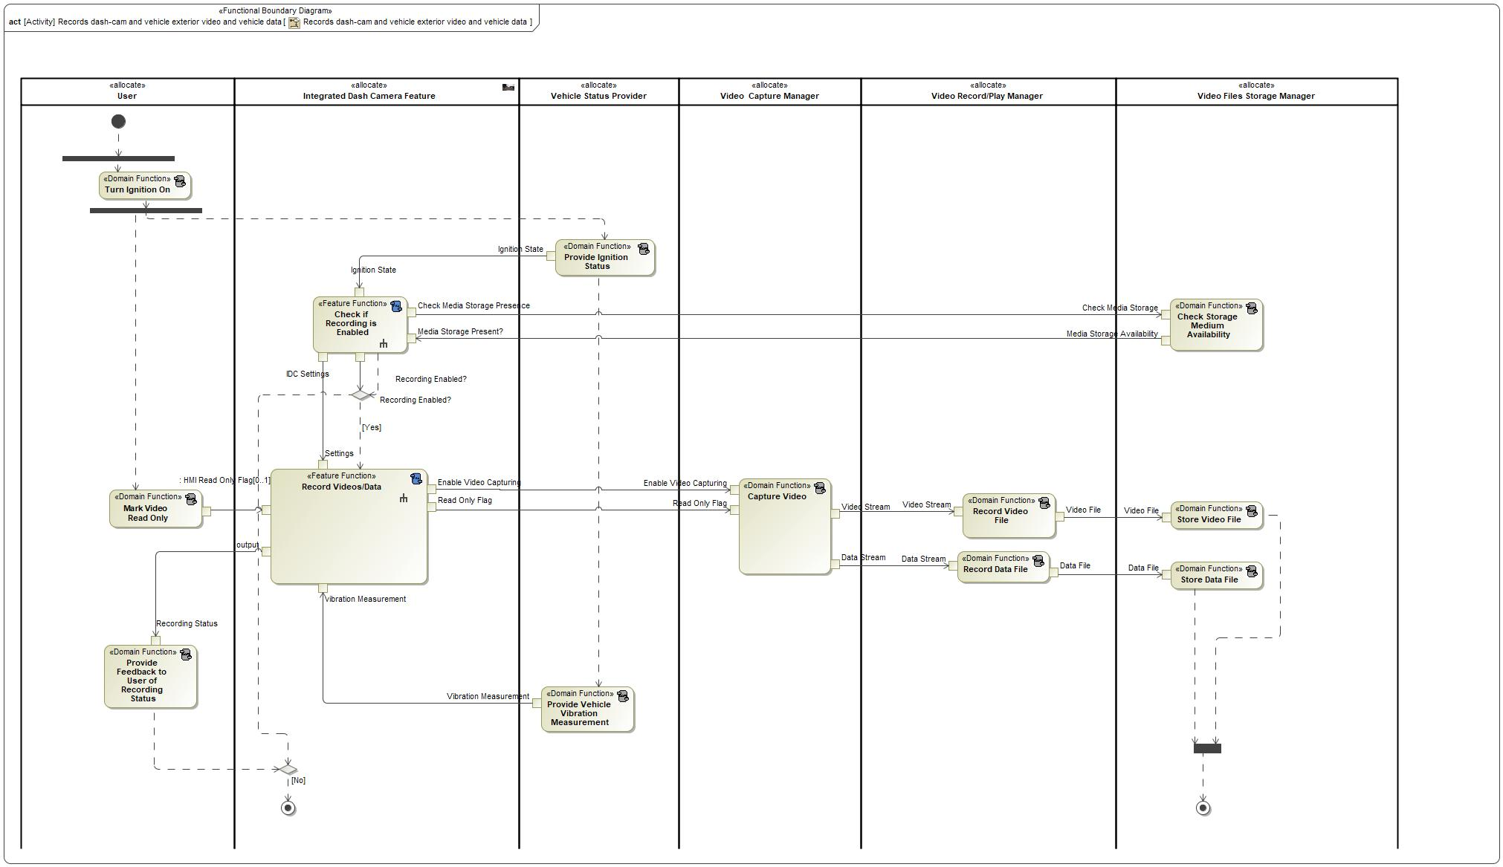

Figure 8: Records dash-cam and vehicle exterior video and vehicle data

### Functions

| **Function Name** | Description | Comments |
| --- | --- | --- |
| *(activity)* Select Manage Library Option | *(activity)* User selecting Video File management commands by selecting the video file on a list and one of these commands:  1- Delete  2-Protect  3-Un-Protect |  |
| *(activity)* Provide Ignition Status | *(activity)* Vehicle Status provider provides IDC with the ignition state at all times. |  |
| *(activity)* Provide Gear Position | *(activity)* Vehicle Status provider provides IDC with the transmission gear state at all times. |  |
| *(activity)* List Saved Videos | *(activity)* When user selects Video Play or Video File Management, IDC starts by asking the Video File Manager for a list of the files stored on the memory device. IDC then displays that list for the user and allows the user to select a video file from the list. |  |
| *(activity)* Manages Stored Video Library | *(activity)* This function allows the user to manage the files stored on the memory device using 3 different commands:  1- Delete  2- Protect  3-Un-Protect |  |
| *(activity)* Perform Delete/Protect/Unprotect | *(activity)* When instructed by IDC, the Video Storage manager shall perform the following functions to the stored files:  1- Delete  2- Protect  3- Un-Protect |  |
| *(activity)* User Select File Management Function | *(activity)* User selecting Video Player commands to control the video play occurring at the time. |  |
| *(activity)* Select Video File | *(activity)* User needs to select the video file to either play or to manage by the video file management system. |  |
| *(action)* Provide Recorded Files Listings  *(activity)* Provide Recorded Files Listings | *(activity)* File storage manager, when instructed by IDC, shall provide the listing of all the video files stored on the memory device. |  |

Table 17: List of Functions on Manages Captured Video Library

| **Function Name** | Description | Comments |
| --- | --- | --- |
| *(activity)* Make HMI Selections | *(activity)* Make Selections is the function where the user selects the entity/command on the selections list on the HMI display. |  |
| *(activity)* Update IDC Settings | *(activity)* This is the function to startup IDC feature. It can be invoked only when:  1- Ignition is On  2- Transmission in P  This function loads up the saved settings from the previous IDC session. If no saved settings exist (first time use after a reset), the feature loads the factory default settings and allows the user to modify them. |  |
| *(activity)* Provide Ignition Status | *(activity)* Vehicle Status provider provides IDC with the ignition state at all times. |  |

Table 17: List of Functions on IDC Setup and Settings

| **Function Name** | Description | Comments |
| --- | --- | --- |
| *(activity)* User Select Video Play Function | *(activity)* User selecting Video Player commands to control the video play occurring at the time. |  |
| *(activity)* Process Video Command | *(activity)* The Video Record and Play manager shall perform the following video commands as instructed by the IDC:  1- Play  2-Stop  3-Resume  4-Pause |  |
| *(activity)* Provide Recorded Files Listings | *(activity)* File storage manager, when instructed by IDC, shall provide the listing of all the video files stored on the memory device. |  |
| *(activity)* List Saved Videos | *(activity)* When user selects Video Play or Video File Management, IDC starts by asking the Video File Manager for a list of the files stored on the memory device. IDC then displays that list for the user and allows the user to select a video file from the list. |  |
| *(activity)* Provide Gear Position | *(activity)* Vehicle Status provider provides IDC with the transmission gear state at all times. |  |
| *(activity)* Display the Video/Data | *(activity)* When playing back videos, IDC processes the recorded video/data overlay stream and sends the processed stream to the vehicle display manager to be displayed to the user. |  |
| *(activity)* Select a Video to Play | *(activity)* Select A Video to Play is the IDC function that presents the user with a list of the video files stored on the memory device and allows the user to select one of the videos to play. |  |
| *(activity)* Select Video File | *(activity)* User needs to select the video file to either play or to manage by the video file management system. |  |
| *(activity)* User Select Video Play Function | *(activity)* User selecting Video Player commands to control the video play occurring at the time. |  |
| *(activity)* Perform Video Functions | *(activity)* Perform Video Functions receives the user video function selection and commands the Vedio Record and Play manager to execute the command. |  |
| *(activity)* Provide Ignition Status | *(activity)* Vehicle Status provider provides IDC with the ignition state at all times. |  |
| *(activity)* Play Selected Video | *(activity)* The Video Record and Play manager when instructed by the IDC would retrieve the video file using the index received from IDC and plays that file. It will send the played video stream back to IDC. |  |
| *(activity)* Display Video Stream | *(activity)* Display Video Streams function receives the played video streams from the Video Record and Play manager and displays the video stream on the available vehicle display. |  |

Table 17: List of Functions on Plays recorded Video on the HMI screen while in park

| **Function Name** | Description | Comments |
| --- | --- | --- |
| *(activity)* Provide Vehicle Vibration Measurement | *(activity)* Vehicle Status Provider provides vehicle body vibration measurement (G-sensor) at all times to the IDC feature. |  |
| *(activity)* Store Data File | *(activity)* File Storage Manager shall receive the Data Files from the Video Record and Play Manager and shall store them to the memory device available. |  |
| *(activity)* Turn Ignition On | *(activity)* User will turn vehicle ignition ON, thus triggering IDC to start recording if Recording was enabled in Settings. |  |
| *(activity)* Record Data File | *(activity)* Video Record and Play manager records the incoming data stream to a video file per the settings. The data file is then transferred to the File Storage Manager. |  |
| *(activity)* Capture Video | *(activity)* Capture Video is the vehicle external view video capturing activity performed by the Video Capturing manager. IDC sends an Enable signal to start Video Capture Activity when ignition is turned on and IDC Recording is enabled in Settings. Video recording will continue until ignition is turned off. |  |
| *(activity)* Record Video File | *(activity)* Video Record and Play manager records the incoming Video stream to a video file per the settings. The video file is then transferred to the File Storage Manager. |  |
| *(activity)* Provide Ignition Status | *(activity)* Vehicle Status provider provides IDC with the ignition state at all times. |  |
| *(activity)* Mark Video Read Only | *(activity)* Video Record and Play manager, when instructed by the feature, will flag the video currently being recorded, by the READ ONLY flag thus protecting it from being overwritten. |  |
| *(activity)* Record Videos/Data | *(activity)* If Ignition is On and Recording is Enabled, IDC starts recording video and data overlays and stores them on the memory storage. |  |
| *(activity)* Check if Recording is Enabled | *(activity)* IDC needs to check settings if Recording is Enabled. This function retrieves Settings from memory and checks the Recording Flag field. |  |
| *(activity)* Provide Feedback to User of Recording Status | *(activity)* User will be informed of the recording status at all times via HMI. |  |
| *(activity)* Store Video File | *(activity)* File Storage Manager shall receive the Video Files from the Video Record and Play Manager and shall store them to the memory device available. |  |
| *(activity)* Check Storage Medium Availability | *(activity)* IDC requests the Video Storage Manager to provide Storage Medium Availability status. IDC will not function unless a memory storage device is available and can be used. |  |

Table 17: List of Functions on Records dash-cam and vehicle exterior video and vehicle data

## Logical Architecture

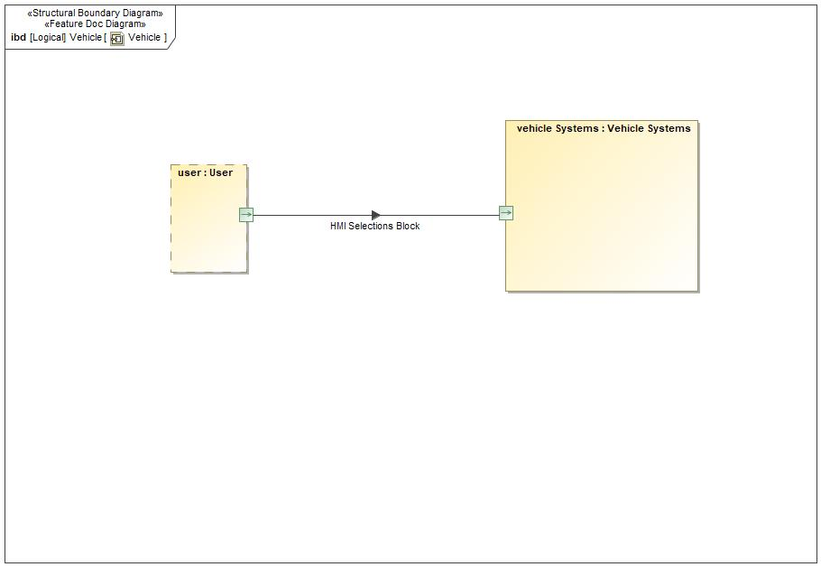

Figure 9: Vehicle

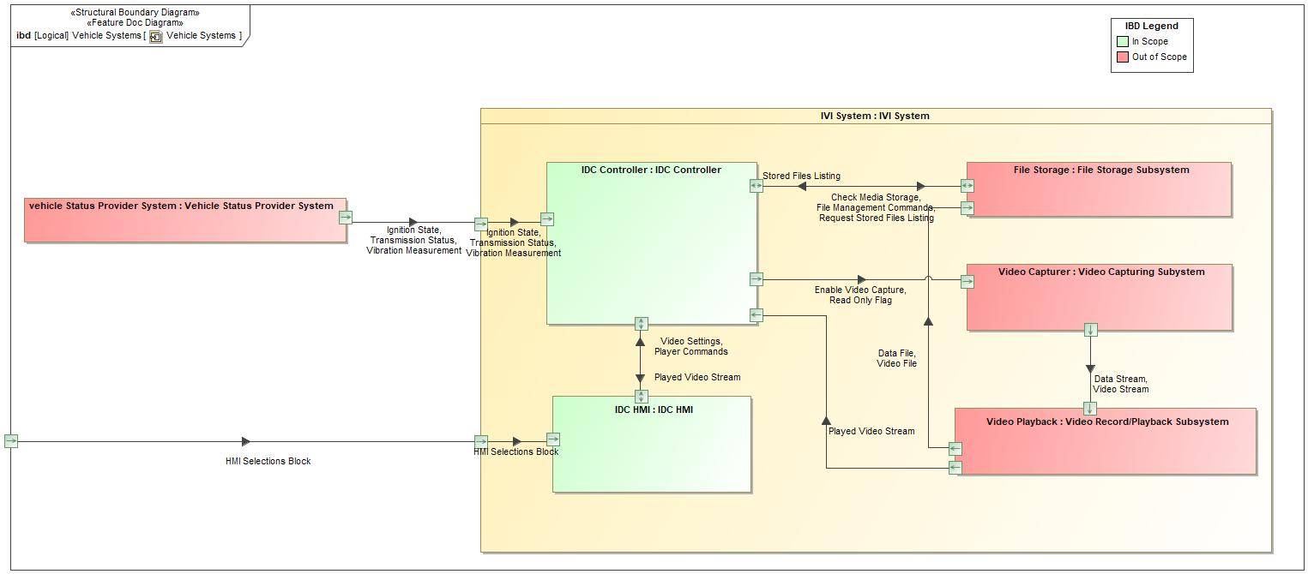

Figure 9: Vehicle Systems

### Logical Elements

|  |  |  |  |
| --- | --- | --- | --- |
| **Element Name** | **Description** | **Allocated Functions** | **Comments** |
| File Storage Subsystem |  |  |  |
| IDC Controller |  | * Request Media Storage Status * Receive Media Storage Status * Store IDC Settings * Retrieve Stored IDC Settings * Detect Request for Stored Files List * Receive Stored Files List * Store IDC Settings * Request Media Storage Status * Receive Media Storage Status |  |
| IDC HMI |  |  |  |
| IVI System |  | * Identify EDC Settings * Read EDC Settings * Process Video Stream * Process Data Stream * Create Video File * Create Data File * Interpret User Selection * Add New Settings * Retrieve Video Settings * Collect Video Streams * Collect Data Streams * Use Stored Settings * Use Default Settings * Update Settings * Check if File Storage is Available * List File Storage files * Select a Video File to Play * Play Selected File * Enable Recording * Receive Recorded Videos Streams * Issue A Read Only Flag * Process Event * Display Settings * Set Recording Status to Enable * Set Recording Status to Disable * Check if IDC is Enabled in Settings * Request Stored Videos List * Receive Stored Videos List * Request to Play the Selected Video * Display the Video Stream * Check if IDC is Enabled in Settings * Check if File Storage is Available * Set Recording Status to Enable or Disable * IVI System Enable Recording * Process Events During Recording * IVI System Issues A Read Only Flag * IVI System Requests Stored Videos List * Request to Play the Selected Video * IVI Display the Video Stream Request * IVI System Receives Stored Videos List |  |
| User |  |  |  |
| Vehicle Status Provider System |  |  |  |
| Vehicle Systems |  |  |  |
| Video Capturing Subystem |  |  |  |
| Video Record/Playback Subsystem |  |  |  |

Table 19: Logical Elements

### Logical Interfaces

|  |  |  |  |
| --- | --- | --- | --- |
| **Interface** | **Direction** | **Description** | **Value Range** |
| Ignition State | p1 (IVI System) To (IDC Controller) |  | On  Off |
| p1 (Vehicle Status Provider System) To p1 (IVI System) |  | On  Off |
| Transmission Status | p1 (IVI System) To (IDC Controller) |  | P  N  D  R  S |
| p1 (Vehicle Status Provider System) To p1 (IVI System) |  | P  N  D  R  S |

Table 19: Feature Interactions on Vehicle Systems

# Traceability Matrix

# Open Concerns

| ID | Concern Description | e-Tracker / Reference | Responsible | Status | Solution |
| --- | --- | --- | --- | --- | --- |
| 1 |  |  |  |  |  |

Table 20: Open Concerns *(Not supported by MagicDraw report generation)*

# Revision History

No Revision History found.

## Template Revisions

|  |  |  |  |  |
| --- | --- | --- | --- | --- |
| Version | Rev. | Date | Description | Responsible |
| 0 | 6 | 2015-05-26 | * Chapter “Feature Overview” and made a 2nd level heading. * Chapter “Feature Modeling” divided into 3 subchapter (“Scenarios”, “Use Cases”, “State Machines”) for different modeling methods | Jbaden1 |
| 0 | 7 | 2015-05-27 | * Table of Content updated * Template Revision History chapter added | Jbaden1 |
| 0 | 8 | 2015-07-02 | * Section “Unsettled Issues” added | Alevin7 |
| 0 | 9 | 2015-08-04 | * Section “Feature Variants” added * Section “Feature Boundary Diagram” renamed to “Feature Context Diagram” * Document Properties adapted to match needs of VBA macros | Jbaden1, Awegman1 |
| 1 | 0 | 2015-09-11 | * Section “Feature Variants” reworked * Feature Goals removed. Only “Safety Goals“ chapter remains. * Heading 2 formatting issues corrected. * Requirements / Use Cases Listing removed from traceability chapter. * Formatting of attribute table in Notation chapter corrected * Open Topics / Known Issues chapter moved to the end | Jbaden1 |
| 1 | 1 | 2015-11-16 | * Table-Styles removed (for smooth VSEM import) * Some clean-up of sections “Purpose” and “Audience” | Awegman1, jbaden1 |
| 1 | 2 | 2016-02-26 | * Minor corrections based on lessons learned from CC and PCL pilot (e.g. section market/regions) and discussion with Functional Safety Team (purpose of feature) * Footer corrected * Boundary diagram interface chapter renamed to influences. | Jbaden1 |
| 1 | 3 | 2016-02-26 | * Minor corrections after review with Whitney Keith from Functional Safety team | Jbaden1 |
| 1 | 4 | 2016-03-10 | * Some cleanup of meta-data in Word Properties | Jbaden1 |
| 1 | 5 | 2016-03-10 | * Footer formatting corrected (Issue 19) * Results from review with Functional Safety Team incorporated (Issue 20). | jbaden1 |
| 1 | 6 | 2016-04-18 | * Scenario Template added | Jbaden1 |
| 1 | 7 | 2016-04-18 | * Chapter “Operation Modes and States” moved before “Use Case” section. | Jbaden1 |
| 1 | 8 | 2016-04-18 | * Broken Wiki links repaired. | Jbaden1 |
| 2 | 0 | 2016-05-19 | * Adapted to Specification_Macros.dotm V2.0 * Requirements Templates chapter (ch. 1.7.1) no longer has an attribute table, but refers directly to the Wiki.. | Jbaden1 |
| 2 | 1 | 2016-06-10 | * Table for Context Diagram modified (lists external entities and Influence Description only) | Jbaden1 |
| 2 | 2 | 2016-07-08 | * Template version added to footer * Several hints added to the various sections * Findings from Functional Safety Team incorporated. * RE_SafetyRequirement style added | Jbaden1 |
| 2 | 3 | 2016-09-21 | * Update from Functional Safety Team incorporated (“Lessons Learned”, “System Behaviors for HARA”) | Jbaden1 |
| 2 | 4 | 2016-11-15 | * Update from Functional Safety Team incorporated (“Lessons Learned”, “System Behaviors for HARA”) * Explanatory notes made more formal | Jbaden1 |
| 3 |  |  | Skipped to synchronize with Specification_Macros.dotm |  |
| 4 |  |
| 5 | 0 | 2017-01-13 | * Meta data updated for specification macros, version 3.1 * SW Unit chapter removed for the time being * Green boxes added for user hints | Jbaden1 |
| 5 | 1 | 2017-01-18 | * Minor editorial changes | Jbaden1 |
| 6 | 0 | 2017-02-03 | * CR48: Chapter 6 renamed from “Safety” to “Functional Safety”. New sub-chapter “Safety” introduced in Non-Functional Requirements section | Jbaden1 |
| 6 | 0 | 2017-04-28 | * CR7: “RequirementsTraceability” chapter removed | Jbaden1 |
| 6 | 0 | 2017-11-15 | * CR32/53: New Cover Sheet + Disclaimer replaces FAP-150 like ones. * CR75: Some rewording -> Terminology to Glossary, Notation -> Document Conventions * CR49: Rename “Assumptions & Constraints” to “Assumptions” * CR74: Safety Assumptions added to chapter 6. * CR58: Add function allocation column to Logical Architecture chapter | Jbaden1 |
| 6 | 0 | 2018-01-31 | * CR63: Updated links to Functional Safety Sharepoint | Jbaden1 |
| 6 | 0 | 2018-07-24 | * CR69: Add FSR to FeatureDoc * CR64: Add new section "Design Requirements" to Function Spec and Feature Spec | Jbaden1 |
| 6 | 0 | 2018-08-06 | * CR53: some corrections for metada and formatting | Jbaden1 |
| 6 | 0 | 2018-09-28 | * Broken links to RE Wiki repaired | Jbaden1 |
| 6 | 0 | 2018-10-31 | * Cover sheet and footer more GIS like. Functional Safety team feedback incorporated:   + New subsections “Functional Safety Requirements, (Decomposed) FSRs and Parameters / Values   + Removal of “Logical Architecture” | Jbaden1 |
| 6 | 0 | 2018-12-12 | * FSR template removed, now as a macro in the Specification_Macros.dotm | Jbaden1 |
| 6 | 0a | 2019-05-23 | * Re-introduce “Logical Architecture” (for Functional Safety) | Jbaden1 |
| 6 | 0b | 2019-06-26 | * Chapter “Logical Elements” in “Logical Architecture” section added (FuSa CR 15136240) | Jbaden1 |
| 6 | 0c | 2019-03-22 | * Chapter “Decomposed FSRs” renamed to “ASIL Decomposition of Functional Safety Requirements” and moved beneath Chapter “Functional Safety Requirements”. Explanatory text improved. | Jbaden1 |
| 6 | 0c | 2019-04-05 | * Some wording in ASIL decomposition table modified. Description of fields in that table improved. | Jbaden1 |
| 6 | 0c | 2019-06-24 | * “Input Requirements” section modified (table approach as for the other RE templates). * “References” and “Glossary” chapter moved to the “Introduction” chapter. | Jbaden1 |
| 6 | 0c | 2019-07-02 | * "Important" box added on cover sheet which points to the macros | Jbaden1 |
| 6 | 0c | 2019-07-02 | * Subsection “Error Handling” removed form chapter “Feature Requirements”->”Functional Requirements” (teams are free to create their own substructure of that section). Note tells author not to forget about error handling. * Hint for chapter “Feature Variants” improved reworded upon request from Functional Safety Team. | Jbaden1 |
| 6 | 0c | 2019-05-11 | * Copyright notice shortened and moved to cover sheet and added to footer (to be compliant [with Ford copyright guidelines](http://www.fgti.ford.com/client/NewFGTI/CopyrightNotice.html)) * Term “Disclaimer” no longer used for what is actually only a copyright notice | Jbaden1 |
| 6 | 0c | 2019-22-11 | * Chapter “Input Requirements/Documentst: minor modifications (examples added), Word comment removed” | Jbaden1 |
| 6 | 0c | 2019-12-05 | * Upstream Documents section added to “Input Requirements/Documents” table * Custom style table formatting removed * Hint on system behaviors modified as requested from FuSa team | Jbaden1 |
| 6 | 0c | 2019-12-09 | * Term “Upstream Documents” replaced by “Attribute Requirements” in “Input Requirements/Documents” table * ASIL Decomposition table replaced by a version, which get not corrupted during VSEM import. | Jbaden1 |
| 6 | 0c | 2019-12-10 | * In ch. “Functional Safety Requirements” Word reference Id by Word reference text replaced.. | Jbaden1 |
| 6 | 1a | 2020-02-12 | * New chapter “Cybersecurity” added. | Jbaden1 |
| 6 | 1a | 2020-03-03 | * All User Hints formatted using style “RE_UserHint” to enable automatic removal by a macro. | Jbaden1 |
| 6 | 1a | 2020-03-04 | * Chapter “Cloud Connectivity Data Analytics Requirements” added upon request by D. Crockett/J. Rawlings | Jbaden1 |
| 6 | 1a | 2020-03-09 | * Missing doc property “LatestSigMappingID” and “LatestAisInterfaceID” added * doc property “CopyrightDate” re-formatted to text and copyright date field in footer corrected * Version numbering re-initialized as 0.1 * Init value of version/revision date set to “yyyy/mm/dd” instead of “yyyy-mm-dd” to be in line with the “Edit Document Property” dialog * type of document property for latest IDs changed to number instead of text | Jbaden1 |
| 6 | 1b | 2020-03-17 | * Chapter “Functional Architecture” renamed to “Functional Decomposition” * New MBSE terminology introduced: “Feature Level”, “Function Level” and “Component Level” renamed to “Concept Level”, “Logical Level” and “Technology Level” | Jbaden1 |
| 6 | 1b | 2020-07-03 | * CR31: Chapter “Traceability Matrix” added. | Jbaden1 |
| 6 | 1b | 2020-23-09 | * CR28: Alignment to [*FFSG01.10 Feature Document Guideline*](https://azureford.sharepoint.com/sites/GlobalFunctionalSafety/Released%20Templates%20Guidelines%20and%20Examples/Guidelines/FFSG01.10_FeatureDocument_Guideline.pdf) for how to apply the Feature Doc template for Functional Safety. New section “Classification of Chapters” added. “Active Tilt Control” Example in section “Logical Architecture” updated based on input from HARA training. | Jbaden1 |
| 6 | 1b | 2020-25-11 | * Reference to process definition in Stages added to “How to Use” section on cover sheet. User hints removed from “Document Purpose” chapter. * RE-Wiki links mostly replaced by Stages links, links to Functional Safety Sharepoint updated | Jbaden1 |

# Appendix

## Definitions

| **Definition** | **Description** |
| --- | --- |
| Action Validation Criteria | Validation criteria for these actions |
| ACTION VALIDATION CRITERIA | Validation criteria for these actions |
| DRIVER ACTIONS OR OTHERS | Description of driver actions or other people |
| Driver Actions or Others | Description of driver actions or other people |
| ECU | Electronic Control Unit |
| FEATURE STATUS | Ex: recording, standby |
| FTTI | Fault Tolerance Time Interval |
| FTTI | Fault Tolerance Time Interval |
| FUNCTIONAL REDUNDANCIES | Functional redundancy - fault tolerance |
| Functional Redundancies | Functional redundancy - fault tolerance |
| HIGH SPEED | Approximately more than 52 mph (83 kph) |
| High speed | Approximately more than 52 mph (83 kph) |
| HMI | Human-Machine Interface |
| HMI |  |
| IDC |  |
| IDC | Insulation Displacement Connector?/International Data Corporation? |
| IGN | Ignition |
| IVI | In-Vehicle Infotainment |
| IVI |  |
| LOW SPEED | Approximately 12 mph to 36 mph (19 kph to 58 kph) |
| Low speed | Approximately 12 to 36 mph (19 to 58 kph ) |
| MEDIUM SPEED | Approximately 36 mph to 52 mph (58 kph to 83 kph) |
| Medium speed | Approximately 36 mph to 52 mph (58 to 83 kph) |
| NFC | Near Field Communications/NFC Entry and Ignition |
| READ ONLY | Ex: video footage locked, cannot edit |
| RECORDING CAPABILITY STATUS | Ex: memory status for loop recording, incident file, not able to record |
| RECORDING STATUS | Ex: recording/not recording |
| RFI | Reduced Functionality Interval |
| RFI | Reduced Functionality Interval |
| term glossary | A term glossary is a table of agreed upon definitions for terms used in project development that may provide clarity or avoid confusion to stakeholders. |
| TERM GLOSSARY | A term glossary is a table of agreed upon definitions for terms used in project development that may provide clarity or avoid confusion to stakeholders. |
| TLA | Three Letter Acronym |
| TLA | Three Letter Acronym |
| VALET MODE | Through NFC: Input is the user uses their card or smart device and puts it close to the device scanner. Output is the unlocking of the doors or ignition of the vehicle. |
| VEHICLE DATA | Ex: speed, GPS, VIN, pedal position |
| Very Low Speed | Approximately 0 to 12 mph (0 to 19 kph) |
| VERY LOW SPEED | Approximately 0 mph to 12 mph (0 kph to 19 kph) |

Table 21: Definitions used in this document

## Abbreviations

| **Abbr.** | **Stands for** |
| --- | --- |

Table 22: Abbreviations used in this document

Document ends here.